

STUDY ON CHILDREN WITHOUT PARENTAL CARE
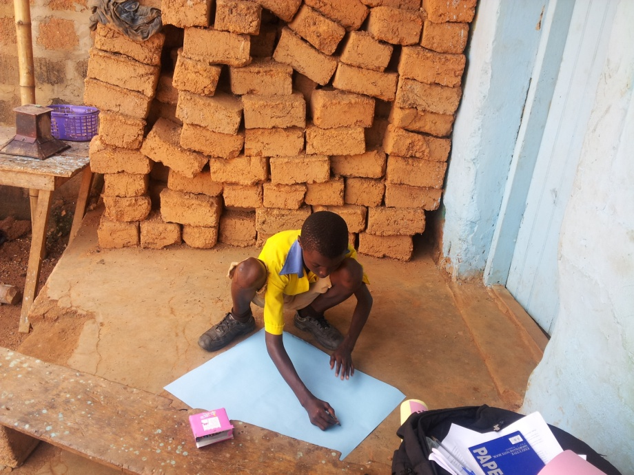

REPORT BY
VEENA JAYARAM, CARLY EDWARDS

Research Director Research Assistant
Mr. James Kofi Annan Mr. David Kofi Awusi

Research Consultant Research Coordinator
Ms. Veena Jayaram Ms. Carly Edwards

ACKNOWLEDGEMENTS
The authors of this report would like to thank the dedicated team of Challenging Heights’ staff, without whose unrelenting support this study would not have been possible. We are particularly thankful to Mr. James Kofi Annan, the Research Director, for providing direction and guidance to the study. Mr. David Kofi Awusi, Programs Manager and Mr. Victor Debi Mensah, Educational Programs Manager at Challenging Heights were instrumental in community and stakeholder engagement for the smooth conduct of the study.
We also wish to thank Mr. Stephen Addo and Ms. Rosemary Afedzie for their continuous assistance and co-operation throughout the duration of the study. A special mention should be made of the survey team whose patience, rigor and devotion to this research resulted in accurate and good quality data. We particularly wish to acknowledge the vital contribution of our two field monitors, Mr. Michael Cobbiah and Mr. Bernard Koomson for their attention to detail and successful management of the field teams. Finally, we would like to extend our gratitude and appreciation to every child respondent, every parent and every stakeholder who was part of this study for believing in this research and providing their valuable time and co-operation.

ABOUT CHALLENGING HEIGHTS
Challenging Heights is a child-centred organization working in Ghana to promote children’s rights to education and freedom from forced labour. The organization was established in 2003 by Mr. James Kofi Annan.
The main focus of Challenging Heights is to creatively and actively empower children through education. The organization enables change through three major interventions – child education, community empowerment and providing support to survivors of child trafficking, child labour and child abuse.
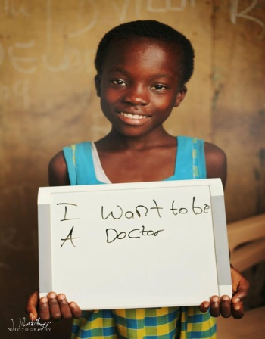
To date the organization has rescued and rehabilitated more than 200 children from various forms of slavery and exploitation, and currently provides subsidized education for nearly 750 children. The organization is constantly seeking out new and innovative ways to achieve its mission and has built a wide network of partners and collaborators over the years to strengthen its work. The organization has also won several international and pan-African awards for its work in Ghana. More information about the organization is available at www.challengingheights.org.

CONTACT INFORMATION
General queries about Challenging Heights and its work may be addressed to infoCHghana@gmail.com. For queries regarding this report, kindly contact edwardscarly@gmail.com

GLOSSARY OF TERMS
CCPC – Community Child Protection Committee
CWPC – Children without Parental Care
DOVVSU – Domestic Violence and Victim Support Unit, Ghana Police
DSW – Department of Social Welfare, Govt. of Ghana
FGD – Focus Group Discussion
ILO – International Labour Organisation
LEAP – Livelihood Empowerment against Poverty Program
MESW – Ministry of Employment and Social Welfare
PRA – Participatory Rural Appraisal
UNICEF – United Nations Children’s Fund

TABLE OF CONTENTS
1. EXECUTIVE SUMMARY 7
2. INTRODUCTION 8
3. RESEARCH OBJECTIVES 9
4. STUDY DESIGN 9
4.1 GEOGRAPHIC SCOPE 9
4.2 METHODOLOGY 11
4.3 SAMPLING 11
4.4 PROTECTION OF CHILD SUBJECTS 12
4.5 THE RESEARCH TEAM 12
5. FINDINGS FROM THE FIELD 13
5.1 DEMOGRAPHICS 13
5.2 PRIMARY PARENTAL CARE INDICATORS 14
5.3 PARENTS’ OCCUPATIONS 17
5.4 SCHOOLING 17
5.5 QUALITY OF LIFE 21
5.6 HEALTH INDICATORS 22
5.6.1 TEEN PREGNANCIES 24
5.7 ECONOMIC ACTIVITIES 24
5.7.1 FARM LABOUR 27
5.7.2 KAYAYO 27
5.7.3 BEGGING/ LEADING THE BLIND 28
5.7.4 MOBILE VENDING 28
5.7.5 STATIONARY VENDORS 29
5.7.6 DRIVERS’ MATE 29
5.7.7 OTHER SECTORS 29
5.8 NETWORKING & EMPOWERMENT 30
5.8.1 INSTITUTIONAL ASSISTANCE 32
5.8.2 AWARENESS ON CHILD RIGHTS 33
5.9 FOOD & SOCIAL SECURITY 33
5.10 HAPPY & SAD EVENTS 35
5.11 SCARY THOUGHTS 36
6. PARTICIPATORY EXERCISES 36
6.1 STORY TELLING 36
6.2 INSTITUTIONAL RANKING 39
6.3 PROBLEM RANKING 42
6.4 CHILD RIGHTS & CONFLICT RESOLUTION 44
7. STAKEHOLDER INSIGHTS 45
7.1 DOVVSU 45
7.2 Department of Social Welfare (DSW) 46
8. RECOMMENDATIONS & CONCLUSION 47
8.1 DISCUSSION – LACK OF PARENTAL CARE 47
8.1.1 Lack of involvement from fathers 47
8.1.2 Family size 47
8.1.3 Lack of education 48
8.1.4 Need for awareness 48
8.1.5 Poverty 48
8.1.6 Inadequate Law Enforcement 48
8.1.7 Community perception on child rights 49
8.1.8 Reuniting migrant children with their families 49
9. LIMITATIONS AND CHALLENGES 49
10. SCOPE FOR FUTURE WORK 50
11. CASE STUDIES 50
12.1 CASE STUDY I 50
12.2 CASE STUDY II 51
12.3 CASE STUDY III 51
12.4 CASE STUDY IV 52
12.5 CASE STUDY V 52
12.6 CASE STUDY VI 53
12.7 CASE STUDY VII 53
12.8 CASE STUDY VIII 54
13 APPENDIX I – ASSETS 54

EXECUTIVE SUMMARY
Ghana has made wide gains in democracy and poverty reduction over the past decade, but incidence of child labour and child trafficking remain a concern. More than 2 million children are estimated to be currently engaged in child labour and thousands of children are trafficked each year to work mainly in the fishing and farming industries.
This research study seeks to understand the issues and needs of children without adequate parental care since these children are the most likely to be victims of child labour/trafficking/abuse. The study was conducted with 260 children in 4 districts in the Central and Greater Accra regions of Ghana. Data collection tools comprised of quantitative surveys, qualitative questions and participatory group exercises with children and parents.
Around 84% of the child respondents lived away from at least one parent, and 31.6% of the sample lived away from both their parents. Children typically suffered from food insecurity (50.3%), physical abuse (8%), illnesses (20%), lack of safe shelter (30.2%) and teen pregnancies (6%), among others.88% of the children were not in school and a majority (90%) of these children wanted to go to school. Only around half (52.5%) of the sample enjoyed a social network capable of providing support (for basic amenities like food and shelter) outside their immediate homes. 54.5% of the children had little or no assets and comforts in the place/room they slept in. More than half the sample (57.3%) engaged in economic activities. The jobs undertaken included fishing, farming, hawking, carrying loads, prostitution and begging with varying hardships and issues.
A sizable number of the children we selected in our sample for having characteristics of a lack of parental care actually either live with one or both parents or see at least one of their parents regularly. This indicates that living with a parent is not a guarantee that a child is getting the care they need. In focus groups, the parents’ failure to recognize their responsibility to their children seems to confirm this. It was observed in the qualitative exercises that parents often viewed children as a burden adding to their expenses. In many cases, parents spoke about their children as earning hands to help ease the difficulties of the household and did not see the benefits in sending them to school. It is imperative that these perceptions should be changed if the children are to be given a chance for meaningful development. Community engagement/sensitization programs may help bring about a paradigm-shift on issues such as child rights, dangers of trafficking and child labour, importance of education and large family size.
Each of the four districts of the study had distinct issues and characteristics and would benefit from tailor-made interventions addressing their unique problems. Generally, for children to enjoy a safe and abuse-free childhood there is a pressing need for programs centred on improving access to and utilization of education, addressing poverty, removing children from forced labour, promoting law enforcement on child abuse and community sensitization towards appropriate behaviour.
Despite their unfavourable circumstances, most of the children we interacted with for this research seemed to know that their way of life was non-ideal and spoke about the need for change (getting back to school, going back home to their parents, ceasing their potentially hazardous work, etc). There is therefore a demand for interventions towards the promotion of child rights and development and these would be well-received by communities, particularly amongst the children.

INTRODUCTION
Child trafficking, child slavery and child labour remain threats to the realization of children’s rights in Ghana. Internal trafficking of children to work in rural areas in fishing and farming are the most common types of trafficking prevalent in Ghana, although some children are also trafficked to work at market places and in prostitution in urban areas. Poverty, lack of education and limited law enforcement have been identified by the International Labour Organization and the UNICEF as the main factors for child labour and child trafficking in Ghana.
More than 2 million children in the country are estimated to be engaged in child labour in various sectors. Children engaged in hazardous child labour or worst forms of child labour are of most concern. In Ghana, sectors contributing to hazardous child labour are reported to be farming, fishing, hawking, transportation of heavy loads and the commercial sex industry.
There are varying estimates on the prevalence of child labour in the country. A report by the United States Department of Labour in 2010 estimated that around 43.5% of the children (between 5-14 years) are engaged in economic activities, as shown in the table below.
 | Age | Percentage
Engaged in Economic Activities | 5-14 years | 43.5%
Attending School | 5-14 years | 83.1%
Combining Work and School | 7-14 years | 18.1%

(Table 1 – Prevalence of Child Labour in Ghana, 2010)
Ghana has made progress with primary school enrolment, but the low secondary and tertiary school enrolment rates (57% and 8% respectively) remain a concern. The overall low school enrolment rates are believed to be largely due to dropouts fuelled by financial constraints and lack of adequate parental care which enable child labour and trafficking.
Thousands of children are trafficked each year within Ghana, to serve as cheap labour mainly in the fishing and farming industries. According to International Labour Organization (ILO) estimates, 70% of trafficking in Ghana is internal, and 78% of the victims are children between ages 4 and 16.
The Government of Ghana has instituted numerous laws and taken multiple steps to combat child labour and child trafficking. One of the recent notable measures was the adoption of a National Plan of Action (NPA) in 2010, a comprehensive framework of initiatives put forward by the Ministry of Employment and Social Welfare (MESW) to eliminate the worst forms of child labour by 2015. Despite all these measures, child labour and traficking continue to remain very real and potential risks faced by under-previledged children in Ghana.

RESEARCH OBJECTIVES
Challenging Heights is constantly seeking out new and innovative means of addressing and reducing the incidence of child labour and trafficking in Ghana. In order to design relevant and meaningful programs for children and communities, there is a need for accurate and current data on the circumstances and reasons for children to be engaged in work. This study was conceptualized to understand what drives children to drop out of school and/or engage in work, their needs and the daily issues faced by them.
The primary objectives of this research are:

  - To determine the services and interventions most needed for children without parental care or who are at-risk of losing parental care to enable them to have a safe childhood with basic needs and remain meaningfully engaged in education.
  - To understand the reasons for the loss of parental care and its potential solutions.

The secondary objectives of this research are:
  - Assess the impact of the currently operational pro-poor programs on the beneficent children/ families.
  - To gain estimates on the number of children living without parental care through discussions with officials and review of national research.
  - To gain data for advocacy and program design.

STUDY DESIGN

GEOGRAPHIC SCOPE
The study was conducted in four districts in the Central and Greater Accra regions of Ghana (see map below). The districts were selected based on reported incidence of high levels child labour. Most of the chosen communities were also reported to be established source and/or destination hubs for trafficking of children, particularly in the fishing industry. The area of the study is depicted in the map below:

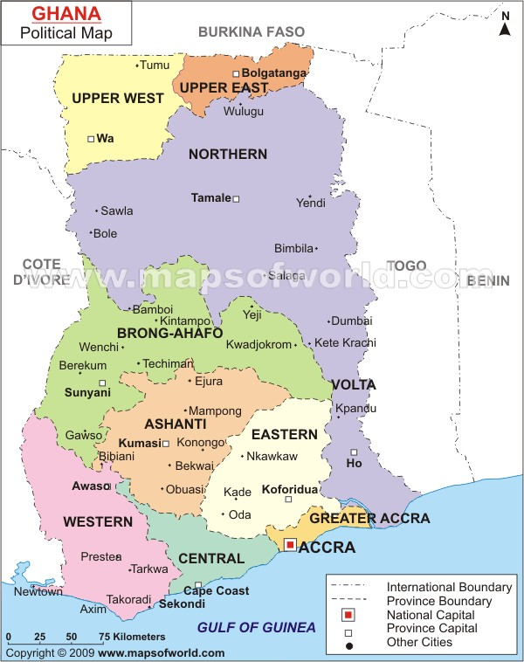

Study Areas

(Fig 1 – Geographic Scope, CWPC Study)
During the time of this research, Challenging Heights was operational in three out of the four selected districts (Effutu Municipal, Awutu Senya and Agona West). In each of these districts, two communities were chosen for the study stratified by the presence of Challenging Heights’ services, as shown in the table below. The communities with Challenging Heights’ presence were chosen randomly. The other communities were chosen based on discussions with relevant stakeholders (local leaders, Community Child Protection Committee members and Challenging Heights’ community engagement staff) on the prevalence of child labour, incidence of child trafficking, school enrolment rates and the general socio-economic issues concerning children in these areas.
S. No | District/ Region | Community Name | Whether served by Challenging Heights? | Notes
 | Awutu Senya  (Central Region) | Kyenkyeso | Yes | A fishing community, reported to be a source-hub for trafficking of children skilled in fishing.
 | Awutu Senya  (Central Region) | Kumasi | No | A fishing community, reported to be a source-hub for trafficking of children skilled in fishing.
 | Effutu Municipal  (Central Region) | Kwendrum | Yes | A fishing community, known to be both a source and destination hub for trafficking of children.
 | Effutu Municipal  (Central Region) | Fetteh | No | A community with high-incidence of school-dropouts and children engaged in economic activities such as hawking and load-carrying. Source hub for trafficking of children.
 | Effutu Municipal  (Central Region) | Zongo | No | Wide prevalence of economically active and school dropped-out children, mainly working at the Zongo Lorry Station.
 | Agona West  (Central Region) | Kukurantumi | Yes | Farming community, children routinely engaged in farm labour. Child trafficking reported to be relatively low.
 | Agona West  (Central Region) | Abodom | No | Farming community, children engaged in farm labour. A community reported to be widely affected by Hepatitis B, resulting in a lot of parental deaths.
 | Kaneshie  (Greater Accra Region) | Kaneshie | No | A destination hub for trafficked children/ children engaged in labour from all parts of the country. Around 82% of the sample interviewed at Kaneshie had migrated there from different parts of the country. The main activities undertaken by children are hawking, load carrying, begging and prostitution.
(Table 2 – Characteristics of study communities)

METHODOLOGY
The data collection methodology comprised mainly of structured interviews with children, focus group discussions (FGDs) with children and with parents/guardians, participatory exercises with the communities and interviews with relevant stakeholders, government officials and local leaders.
Around 260 children were interviewed for the study from the selected communities. Structured surveys comprising of qualitative and quantitative questions were administered to the selected children. Questions on family, health history, education, parental care, employment (if any), social and food security, networking, empowerment, child rights, major life events, quality of life and day-to-day issues and activities were administered to every child respondent. Additional information was captured on physical or other abuse, teenage pregnancy and related issues wherever applicable.
Group exercises were conducted in select communities with children to understand their perceptions and awareness levels on parental care, risks they face, rights they are entitled to, other challenges, etc. FGDs and exercises were also undertaken with parents/guardians of at-risk children to understand their perspectives of child labour and child rights and the issues faced by them in rendering parental care. Information was also sought from the parents on the problems facing the children and the potential solutions.
Interviews were also conducted with the village chief and/or assembly leaders in each community, Community Child Protection Committee (CCPC) members, officials of the Department of Social Welfare and the Ghana Police. Questions were asked on issues facing the communities, their causes, measures taken to combat them and recommended solutions and services for the communities.

SAMPLING
Around 65 children were interviewed in each of the four districts (over-sampled by around 10% above the requirement). Sampling was the most challenging aspect of the study since the criteria did not encompass easily observable characteristics. The sampling methodology was therefore purposive in nature, designed to find children who lacked parental care or some select aspect of it, as summarized in the table below:
SAMPLING CRITERIA
 | Age | Child should be between 8-17 years of age
 | Lack of adequate parental care indicators  (At least ONE should be applicable) | - The child is not in school  - The child is in school but does not have food security  - The child is in school but engages in child labour  - The child is in school but does not have a home
 | The sample is to be balanced by age, occupation, gender, abilities, schooling and other characteristics.
(Table 3 – Sampling Criteria)
In every community, the study team visited the markets, street shops, fishing hubs and farms to identify children engaged in child labour. Children who were seen working during school-hours on week days were asked preliminary questions about why they were not in school. Help was also sought from the members in every community in identifying children who met the sampling criteria. The research team also visited schools in the study districts for identifying school-going children who lacked parental care. School head-masters and class teachers were instrumental in providing information on children who had insufficient parental care, i.e. consistently came to school without food or money to buy food.

PROTECTION OF CHILD SUBJECTS
Every child who was identified as a potential respondent was explained the purpose of the study and what it entailed. Informed Consent was taken from the children and their parents/guardians for participating in the study. In some cases, there were no parents/guardians for the children. In such cases, only the consent of the child could be obtained.
Challenging Heights has a Child Protection Policy which is a comprehensive code of conduct for engaging with children. The entire research team was trained in all aspects of the policy and required to follow the prescribed guidelines throughout the study.

THE RESEARCH TEAM
The research field team consisted of a gender-balanced group of eight qualified field-investigators and two field monitors, under direct supervision of the Research Consultant. People who were well-versed with the required local dialects, trained in survey administration and who had professional experience in dealing with children were chosen to be part of the study. The team underwent a comprehensive one-week training program and a field-based piloting program prior to the actual fieldwork.

FINDINGS FROM THE FIELD
The sections below present the characteristics of the sample as well as data on the issues faced by them. It is useful to study the profile of the child respondents before looking at their problems and needs.

DEMOGRAPHICS
The cross tabulation table below shows gives the gender and age profile of the child respondents.
 | B3_Respondent Age
B2_Resp_Gender | <=8 years | 8-14 years | 15-17 years | Grand Total
Male | 3 | 94 | 47 | 144
Female | 2 | 62 | 54 | 118
Grand Total | 5 | 156 | 101 | 262
(Table 4 – Age-Gender Crosstab, CWPC respondents)
Majority of the respondents were in the 8-14 years category. However, the number of girls in this bracket was only about 2/3rd the number of male respondents. This was partly by design and partly due to availability. Children who were less than 8 years were occasionally interviewed if found to be able to understand and answer the questions. As much as possible, attempts were made to get a balanced sample in terms of age, gender and characteristics.
The religion and language profiles of the respondents are given below. 90% of the respondents were Christian. Traditional religion was encountered only in Effutu Municipal district. Islam and children reporting no faith were found in each of the study areas.
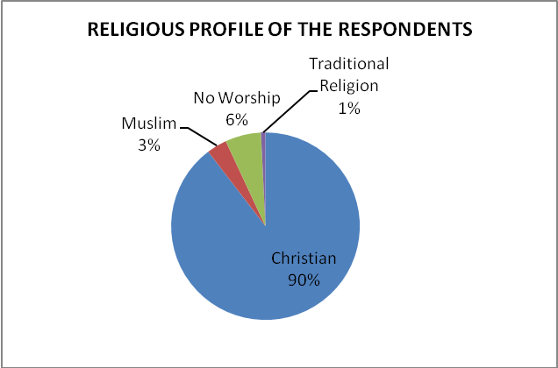
(Graph 1a – Religious Profile of the Respondents, CWPC Study)

During the course of the study, children speaking diverse languages were encountered. This was one of the potential challenges for this research. However, the field teams consisted of investigators from the study areas who could speak the local languages; therefore, language was not a barrier.
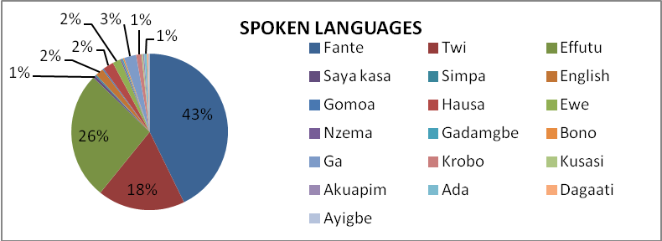
(Graph 1b – Language Profile of the respondents, CWPC Study)
The children often spoke multiple languages. At least one of Twi, Fante or Effutu was known to more than 95% of the children. 31.5% of the children could speak more than one language and the maximum number of languages spoken by a child was five.

PRIMARY PARENTAL CARE INDICATORS
A basic indicator for parental care is often assumed to be the presence or absence of parents in the child’s day-to-day life. However, an important finding from this research is that many of the children we selected in our sample for having characteristics of a lack of parental care are actually living with one or both of their parents. This may indicate that simply living with a parent is not a guarantee that a child is getting the care they should be afforded. Almost half the respondents lived in their parents’ (mother and/or father) house and around 30% of the children lived with other relatives. A sizeable portion of the sample (16%) reported to be living and sleeping on the streets. A small number of children reported living with their master/madam, at a friend’s house, in a broken down car, or with a family friend.
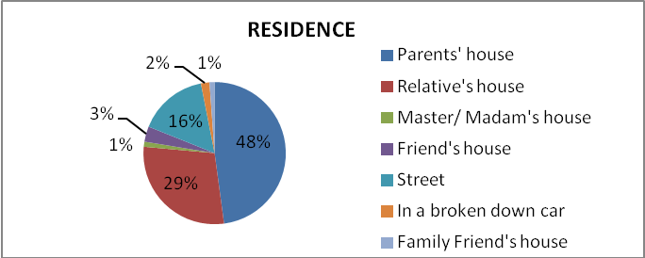

(Graph 2 – Residence Profile of the Respondents, CWPC Study)
Although around half of the respondents lived in their parent’s house, only around 15% of the children lived with both parents and 33% of the sample stated that at least one parent lived inaccessibly far away from them. It is also noteworthy that almost a quarter of the sample had lost one or both parents.
 | B12_Father_Residence
B7.1_Mother_Residence | In the same house as the respondent | Within the community | In a neighbouring town/ village | In a town/  village far-off | Out of country | Deceased | Grand Total
Row Labels
In the same house as the respondent | 40 | 40 | 3 | 18 | 2 | 18 | 121
Within the community | 6 | 10 | 3 | 2 | 1 | 1 | 23
In a neighbouring town/ village | 1 | 7 | 5 | 3 | 1 | 5 | 22
In a town/village far-off | 5 | 5 | 2 | 28 | 0 | 7 | 47
Out-of-country | 0 |  | 2 | 1 | 3 | 0 | 6
Deceased | 5 | 4 | 0 | 5 | 0 | 17 | 31
Grand Total | 57 | 66 | 15 | 57 | 7 | 48 | 250
(Table 5 – Parents’ Residence Crosstab, CWPC Study)

S. No | B8_B13_Parents_Residence_Summary
 | Percentage of respondents living away from both parents | 31.6%
 | Percentage of respondents living away from their mother | 42.4%
 | Percentage of respondents living away from the father | 50.8%
(Table 6 – Parents’ Residence, CWPC Study)
Data on reasons for the separation from parents and their accessibility was also collected. However, in many cases, the children did not know why they were separated from their parents and often could not recollect the last time they met their mother/father. 90% of the children who stayed away from their father and 60% of the children who stayed away from their mother said that it was not their choice to be separated. A snapshot of the reasons for the separation stated by the children is given below:
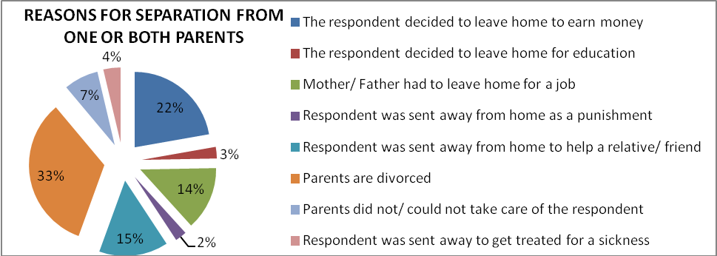
(Graph 3 – Reason for separation from parents, CWPC study)
Divorce of parents is the single biggest reason for children being separated from them. In the group exercises, children were very vocal about how they were negatively affected by their parents’ marriages falling apart. In the qualitative section of the survey, divorce of parents is the most frequently reported sad event of children’s lives, second only to death of parents/ loved ones.
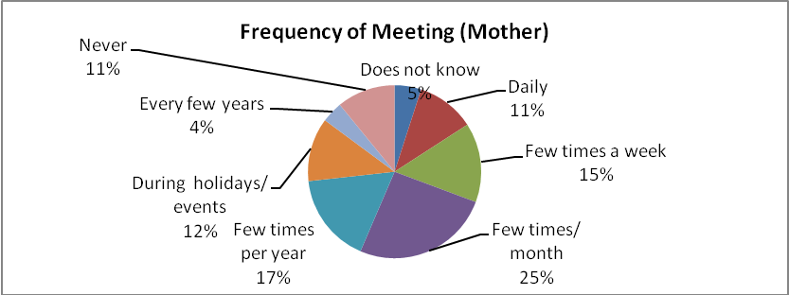
44% of the children who did not stay with their mother met her a few times a year or less and around 11% of the children reported never having known their mother. Correspondingly, around half the respondents (51%) meet their father a few times a year or less frequently.

(Graph 4a – Frequency of meeting with the mother, CWPC study)
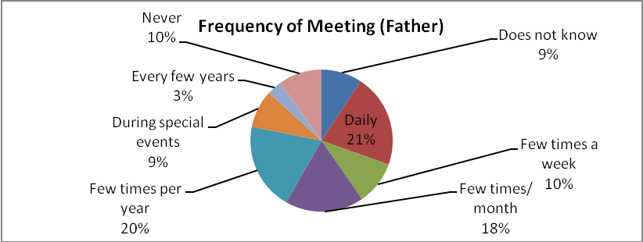

(Graph 4b – Frequency of meeting with the father, CWPC study)
Interestingly the percentage of children in this study who see their fathers daily is almost twice those who get to see their mothers everyday. This is a revelation to ponder upon, perhaps indicating that children living with their fathers can still be quite succeptible to experiencing a lack of necessary care and that children who see their mothers more often are less likely to meet the criteria to be sampled for this research.
In most cases, separation from parents was not voluntary – 90% of children who were away from their fathers and around 60% of the children who were away from their mothers reported that it was not their choice to stay away. In some cases, children did not know the reasons for being sent away or taken away from their homes. In the qualitative section of the surveys, many children spoke about the pain of being separated from parents.
“Whenever my mother visits me, I will be very happy. The day they took me from my mother was the saddest day of my life” says a 13-year old respondent from Kaneshie who was sent away from her home to help an aunt. She is the eldest of six children and has no father. She is unable to recollect when she last saw her mother since she left home.

PARENTS’ OCCUPATIONS
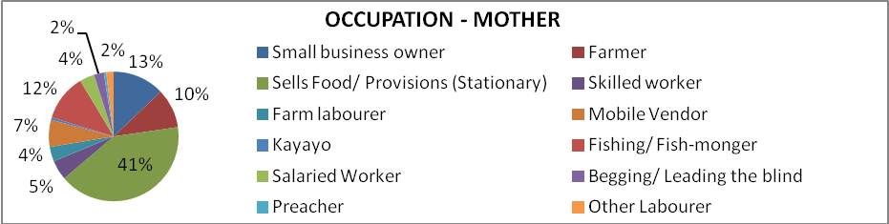
Around 16% of the children had mothers who did not work (around 5% of these cases were due to health issues). The rest of the sample had working mothers. Their occupations are depicted below. A substantial number of mothers were selling food/ foodstuff (41%).
(Graph 5a – Parents’ Occupation - Mother, CWPC study)
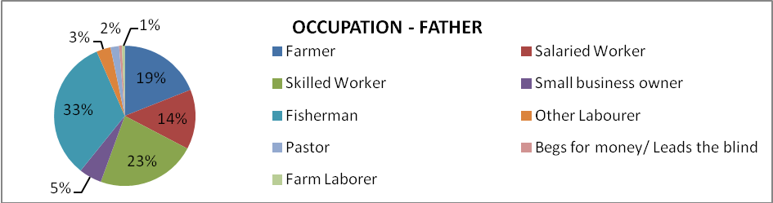
Correspondingly, only around 9% of the children had fathers who did not work. Around a third of the children interviewed reported that their fathers were fishermen. 23% of the children said that their fathers were skilled workers (masonry, carpentry & tailoring) as shown below:
(Graph 5b – Parents’ Occupation - Father, CWPC study)

SCHOOLING
A substantial majority (88%) of the children interviewed were not in school, despite being of school-going age. 8.7% of the children had never attended school in their lives; the rest of the children were school-dropouts.
Financial constraints were the major reported reason why children dropped out of school in the sample (see chart below). 91.6% of the children who reported dropping out of school due to financial troubles said that they were interested in pursuing schooling.
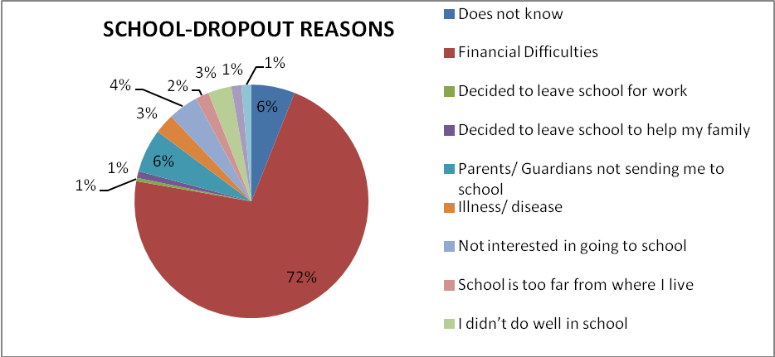
(Graph 6a – School-dropout reasons, CWPC study)
In the qualitative sections of the survey, many of the girls interviewed revealed that they were required to give up schooling so that their brothers could attend school, to their great disappointment. These children said that they were expected to stay and home and support their siblings by taking care of them.
Around 90% of the children who dropped out of school (overall figures) reported that they would like to continue their education; most children were very vocal about this. Children spoke about how they envy their friends and siblings who go to school, how they had to forfeit schooling despite getting admission and how their relatives/guardians talked them into leaving their homes with the false promises of education, among other things. The reasons stated by the children who want to pursue schooling are shown below:
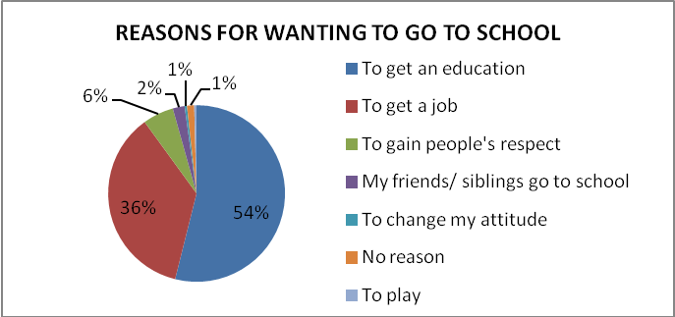
(Graph 6b – Reasons for wanting to pursue schooling, CWPC study)
However, it is also important to understand the reasons why some children said that they do not want to pursue schooling. The reasons indicated by them are given below, arranged by frequency of responses:
Reasons for not wanting to pursue schooling
Want to learn a trade instead | 59%
There is no use of going to school | 6%
Can earn money by working instead | 29%
No reason | 6%
(Table 7 – Reasons for not pursuing schooling, CWPC study)
Importantly, almost all (91%) of the children in the above table were of the ages between 15-18 years. This could explain their decision to drop out of school and pursue a trade/ job. This also indicates that nearly all of the children under 15 reported wanting to attend school.
The correlation between schooling of parents and that of their children was examined. A simple correlation was done on the school attendance of children and their parents. The results are shown below:
 | C2a_Currently_Schooling | B9_Mother_Attend_School
C2a_Currently_Schooling | 1
B9_Mother_Attend_School | 0.017174121 | 1
(Table 8a –Correlation between the children and their mothers’ schooling, CWPC study)
 | C2a_Currently_Schooling | B14_Father_Attend_School
C2a_Currently_Schooling | 1
B14_Father_Attend_School | 0.002545 | 1
(Table 8b –Correlation between the children and their father’s schooling, CWPC study)
 | B26_Parents_Attend_School | C2a_Currently_Schooling
B26_Parents_Attend_School | 1
C2a_Currently_Schooling | 0.064859 | 1
(Table 8c –Correlation between the children and their parents’ schooling, CWPC study)
It is interesting to note the relatively low coefficient of correlation for either parent’s schooling and both parents’ schooling with their children’s. This simply means the parents’ schooling (either or both) does not appear to influence the child’s schooling significantly. For instance, from Table 8c, we see that even if both parents have been to school, there is only a 6.48% chance that the child will be in school. However, it should also be noted that this study did not collect the level of schooling that parents attained and was the children’s reported perception on their parents’ schooling.
12% of the children interviewed were in school. In most of these cases, although the children were enrolled in school, it was found that their attendance was sporadic. Most of these children worked for a living and attended school only when they could. It is therefore useful to look at additional indicators such as amount of time spent by them on studying on a daily basis and the number of days of school attendance in a week.
“Though I am 14 years old, I am still in class 5” says a respondent from the village of Kukurantumi. “I pluck coconuts, carry blocks & sand and chop up firewood for money. I can make up to 5 Ghana cedis ($2.5) a day and have been working for 2 years now”.
The boy spends 6 hours working each day after school and he is the fourth child of seven children.“ My mother cooks and sells banku (a staple-food made of maize) and we have no father” he says. “Carrying sand is very fatiguing. But I have to do it”

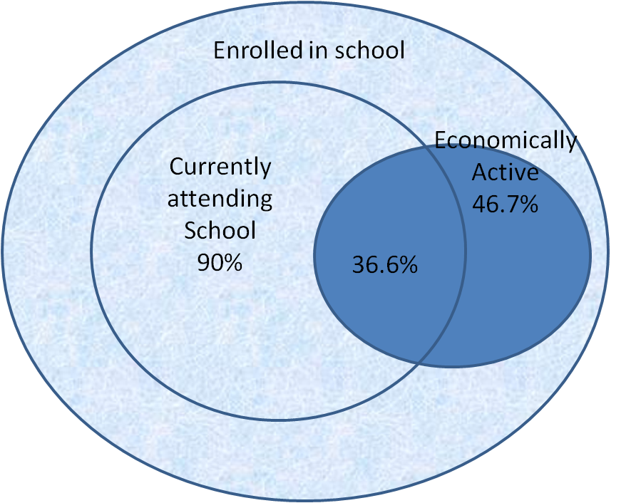
The average school attendance was 3.25 days per week. 10% of the school-going children had zero attendance in the week prior to the survey and only 40% of the children had 100% attendance. An additional 30% of the children did not report schooling in their daily activities, although they claimed to be going to school. Only 27.5% of the school-going children spent time studying after school. 63.3% of school-going children were economically active.

(Graph 7a – Venn Diagram –School Enrolment & Economic Activity, CWPC study)
A typical day for every child in school was captured using an activity chart. The chart below represents the average time allocated by school-going children for various activities in a day.
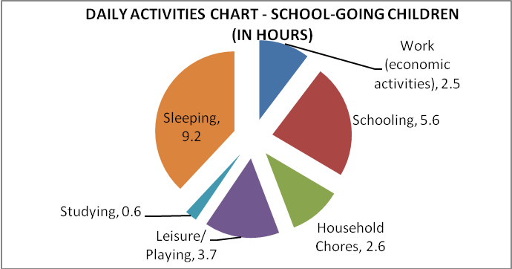

(Graph 7b – Daily activity chart, school-going children, CWPC study)
It is heartening to note that schooling and leisure comprise a major portion of the day. However, these children have other issues such as food insecurity, lack of adequate shelter and physical abuse. This is elaborated on in the table below:
ISSUES FACED BY SCHOOL-GOING CHILDREN
Indicator | Description | Percentage of (school-going ) respondents
Food insecurity | Skipped a meal in the last week due to lack of food/ went without an entire day of food in the week prior to the survey | 36.7%
Lack of adequate shelter | Slept in a place they did not feel safe in/ had instances where they had no place to sleep | 26.7%
Physical abuse at home/ place they stay | Physically abused by people with an intention of causing harm in the last one month | 6.7%
Physical Abuse at school | Physical abuse by teachers/ others at school | 36.7%
(Table 9 – Issues faced by school-going children, CWPC study)
In the qualitative section of the section of the surveys, children were asked what they liked and disliked about their schools. The responses are given below, arranged by frequency:
S.No | What makes children happy at school | Percentage of respondents from the sample
1. | Good teachers who taught well | 50%
2. | Playing Football | 9.3%
3. | Support provided by their friends and teachers at school | 6.3%
4. | Not happy at school | 31.3%
5. | Do not know/ refused to answer | 3.1%
(Table 10a – Reasons for being happy at school, CWPC study)
S. No | What makes children unhappy at school | Percentage of respondents from the sample
1. | Being beaten/caned by teachers | 28.1%
2. | Ridicule/bullying by other children | 18.8%
3. | Jobs like weeding mandated by the school | 3.1%
4. | Do not know/refused to answer | 50%
(Table 10b – Reasons for being unhappy at school, CWPC study)

QUALITY OF LIFE
The household assets available in the room where the children sleep were recorded for each child to get an indication of their socio-economic condition and quality of life. However, it should be noted that these are complex indicators and a mere assessment of the assets may not be sufficient to study them. Nonetheless, an attempt has been made to gauge the quality of life through an index that is calculated from the reported assets and select living conditions (Refer to Appendix I). The results are summarized below:
S. No | Index Value | Definition | % of respondents in the sample
1. | 0-0.19 | Very poor living conditions with lack of even the most basic facilities | 21.2%
2. | 0.2-0.39 | Basic and bare minimal facilities only | 33.3%
3. | 0.4 – 0.59 | Adequate facilities but with no luxuries | 27.05%
4. | 0.6 – 0.79 | Reasonably good standard of living some luxuries (such as TV, Radio etc) | 18.43%
5. | 0.8 – 1 | Very comfortable standard of living | 2.4%
(Table 11 – Quality of Life, CWPC study)
As part of the qualitative interviews children were also asked what they liked most and least about their home. The tables below give a snapshot of the responses which were varied in nature. Only around 40% of the children had anything positive to share.
S. No | What makes children happy about their home | Percentage of respondents from the sample
 | Having friends/siblings to play with | 10%
 | Watching TV/listening to music | 8.8%
 | Affection/care from people at home | 6.3%
 | Getting good food to eat | 2.9%
 | The place is nice (neat/plenty of light/no mosquitoes etc) | 5.4%
 | Freedom/peace of mind | 1.7%
(Table 12a – Reasons for being happy at home, CWPC study)
Interestingly even less children, 24%, were able to articulately describe what they disliked about their homes, as shown in the table below:

S. No | What makes children unhappy about their home | Percentage of respondents
 | The place is dirty/full of mosquitoes | 7.7%
 | They feel insecure/endangered (due to thieves/armed robbers/men who rape/condition of the house) | 5.02%
 | Parents/guardians shout at them/abuse them | 4.6%
 | No toilet facilities in the house | 2.9%
 | They are made to do a lot of household work | 2.1%
 | Landlords/owners harass them | 1.7%
(Table 12b – Reasons for being unhappy at home, CWPC study)

HEALTH INDICATORS
Basic health information was collected for all respondents and their parents. 15.8% of the children reported that their mother was currently ill (at the time of the survey). Out of these, 68.2% of the cases were long-term illnesses (>= 1 year) and 7.3% had multiple illnesses. The conditions included asthma, sickle-celled anaemia, mental illnesses and being crippled among others. The pivot table below gives snap shot of the illnesses and their duration.
 | Column Labels
Row Labels | <=1 week | <=1 month | <=1 year | 1-5 years | > 5 years | Total
Asthma |  |  |  | 1 | 1 | 2
Body Ache/Fever | 1 | 3 | 5 | 6 | 2 | 16
Handicap (Cripple/Blind/Speech-impaired) |  |  |  |  | 4 | 4
Diarrhoea | 1 |  |  |  |  | 1
Eye problem |  |  |  | 4 |  | 4
Heart Problem/Blood Pressure |  | 2 |  | 6 | 1 | 9
Madness |  |  |  | 1 |  | 1
Migraines | 1 | 1 | 1 | 1 |  | 4
Sickle-cell anaemia |  |  | 1 |  |  | 1
Skin condition | 1 |  |  |  |  | 1
Ulcers |  |  | 1 | 1 |  | 2
Total | 4 | 5 | 8 | 21 | 7 | 45
(Table 13a – Health Issues - Mother, CWPC study)
Correspondingly, only around 9% of the children interviewed reported fathers with health issues (during the time of the survey). Interestingly, all these cases were long-term illnesses (>= 1 year), but none of them had multiple conditions.

 | Column Labels
Row Labels | 1-5 years | >= 5 years | Grand Total
Amputated Arm | 1 | 1 | 2
Body Ache | 5 |  | 5
Crippled/ Leg Injury | 3 |  | 3
Eye Problem | 1 |  | 1
Nose Injury | 1 |  | 1
Spiritual Problem | 1 |  | 1
Stomach Problem | 1 |  | 1
Grand Total | 13 | 1 | 14
(Table 13b – Health Issues - Father, CWPC study)
20% of the children interviewed for the study stated that they were ill/had health issues. It should be mentioned that the more than an third of these cases were from the Agona West district, where 43% of the children did not have one or both parents. The conditions of the children (overall) as self-reported are shown below:
(Table 13c – Children’s Health Issues, CWPC study)
 | Column Labels
Row Labels | <= 1 week | <= 1 month | <= 1 year | 1-5 years | >= 5 years | Grand Total
Anaemia |  |  |  | 1 |  | 1
Blood discharge |  |  |  | 2 |  | 2
Body Ache | 8 |  | 2 | 11 | 2 | 23
Disability |  |  |  | 1 |  | 1
Eye Problem |  |  |  | 1 | 2 | 3
Fever | 3 | 1 | 1 | 2 |  | 7
Heart Problem |  |  |  | 2 |  | 2
Hernia |  |  |  |  | 1 | 1
Migraines |  |  | 1 |  |  | 1
Skin Condition | 3 |  |  | 1 |  | 4
Spiritual Sickness |  |  |  | 2 |  | 2
Typhoid |  |  |  | 1 |  | 1
Ulcer |  |  |  | 2 | 1 | 3
Grand Total | 14 | 1 | 4 | 26 | 6 | 51

TEEN PREGNANCIES
Around 6% of the girls interviewed were teen mothers or pregnant at the time of survey. All these children stated that they dropped out of school as a consequence. Although all girls reported that the father of the child provided them with financial help, many of them expressed unhappiness over their situation.
“The day I found out I was pregnant was the worst day of my life” says a 17-year old girl from Abodom. “It has made it impossible for me to continue my education”.

ECONOMIC ACTIVITIES
More than half (57.3%) of the respondents were engaged in economic activities, and only 7% of these children were in school. An additional 10% of the children described activities that would be classified as work for the purposes of this study but these children did not know/think they were working. Out of the children who were working, a majority of them had one job, the maximum number of jobs per child being four.
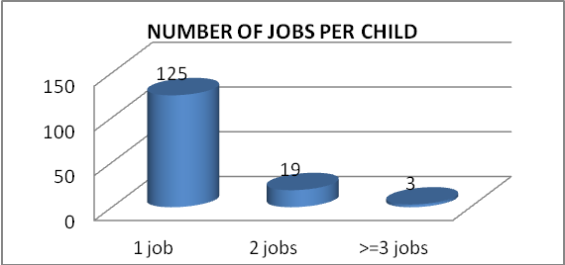

(Graph 8 – Number of jobs undertaken by economically active children, CWPC study)
A substantial portion of the economically active children were engaged in farm labour, Kayayo, hawking and small-scale businesses (see graph below).
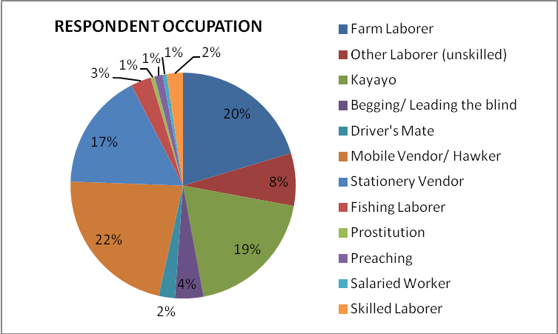
(Graph 9 – Respondent Occupation, CWPC study)
Each of the sectors is described in detail in the sub-sections below. Questions were administered on the nature of work, the hardships faced, the payment earned, how long and why they were engaged in this work, whether they had friends doing similar work, number of hours worked each day, etc. These are analysed in the backdrop of the respective sectors in the later sections of this report.
In general, the average number of hours worked per day per child was 6.8. Since the mean hours worked can be too simplistic a measure, the basic summary statistics for hours worked is calculated in the adjacent table.
B4b_Daily_Work_Hours
Mean | 6.796703
Median | 6
Mode | 12
Standard Deviation | 3.409935
Sample Variance | 11.62766
Minimum | 1
Maximum | 17
Confidence Level (95.0%) | 0.710153
Interestingly, we see that the median~mean, and mode is around twice the mean. This simply means that in this case, 6.8 is also the centrally occurring data point besides being the average and 12 hours/day is the most commonly occurring data point in the sample.
(Table 14 – Hours worked/ day, CWPC study)
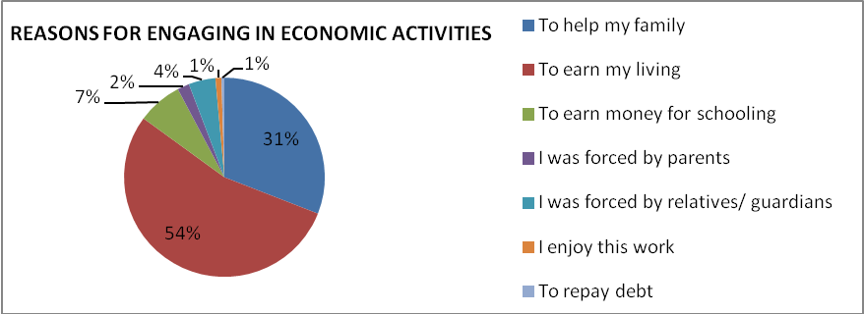
It is also useful to understand why children were engaged in any kind of work. The reasons stated by the respondents are given below:
(Graph 10a – Reasons for engaging in work, CWPC study)
More than half (54%) of working children stated that they worked to earn their livelihood and around 34% were working to support their families. The graph below gives a glimpse into how long the children in the sample have been economically active.
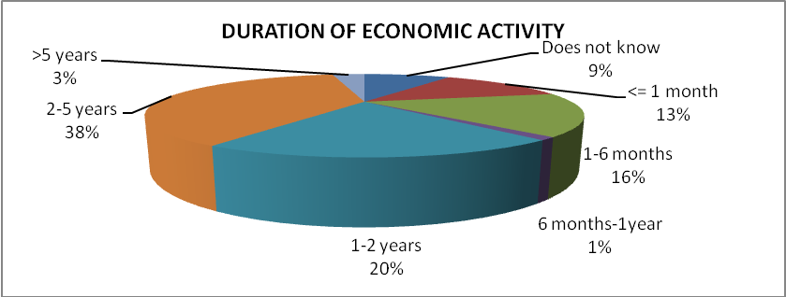

(Graph 10b – Duration of economic activity, CWPC study)
The graph below gives the average time spent by economically active children on different activities in a day. It should be noted that the time spent working will vary with the nature of the job undertaken.
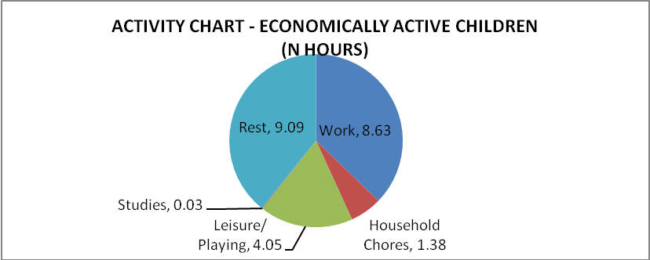
(Graph 11 – Activity Chart, Economically Active Children, CWPC study)

FARM LABOUR
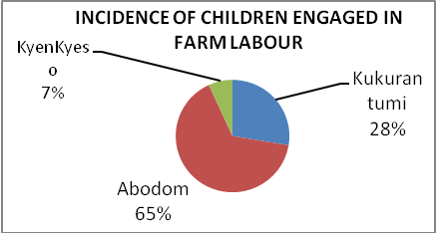
Of all the occupations reported, farm labour seems to be one of the most physically threatening activities. During the interviews and group exercises, respondents spoke strongly about farm labour being unsuitable for children, citing all the daily dangers they encounter when farming.
(Graph 12 – Incidence of child farm labour, CWPC study)
20% of the working respondents worked on farms. Agona West district had the highest incidences of farm labour. The communities of Abodom and Kukurantumi accounted for 93% of the farm labour cases in the sample (see graph).
The most commonly undertaken farming activities by children are weeding, harvesting, snail-hunting, oil brewing and carrying farm produce. Children make anywhere between Ghc 0.5 ($0.25) to Ghc 20 ($10) a day at the farm. The payment depends on amount of hours worked. The average pay per hour is Ghc 0.86 ($0.43).
“I get nightmares that people will wake me up and tell me to go to the farm” says a 10-year old boy from Abodom who stopped schooling when both his parents died.
He lives on the streets and works 12 hours a day as a farm labourer. “It is very tiring. If the produce gets spoilt, I don’t get paid, for no fault of mine” he reveals.

76% of the children reported hardships faced when working on the farm. These include fatigue, snake-bites, falling out of trees, injury from handling cutlasses/machetes & other farm equipment and unfair treatment by employers. This is shown in the table below.
S. No | Hardship Reported | % of respondents (engaged in farm labour)
 | Fatigue | 51.7%
 | Snake bites & other injuries | 20.6%
 | Ill-treatment by employer | 31.0%
(Table 15 – Hardships Reported, Child Farm Labour, CWPC study)

KAYAYO
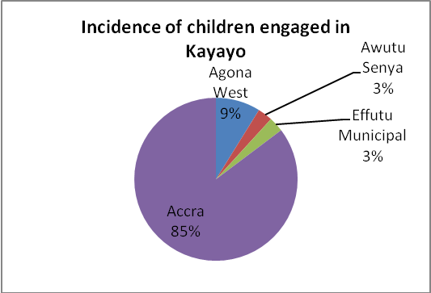
All the four districts of the study had children engaged in Kayayo. However, the incidence was highest in Accra (Kaneshie), where more than a third of the sample (38.7%) comprised of children working as Kayayo.
Children carry loads and assist in transportation of heavy goods from place to place. Kaneshie Market and Kaneshie Lorry Station are hubs for this business since a lot of goods and farm produce is handled in these areas.
The average wage per day earned by children was Ghc 8.62 ($4.31). The per-hour wage is Ghc 1.14 ($0.57). (Graph 13 – Incidence of children engaged in Kayayo, CWPC study)
This work is potentially very tiring, especially for younger children. 66.7% of the children complained of severe fatigue. The table below gives the hardships reported by children engaged in Kayayo.
S. No | Hardship Reported | % of respondents (engaged in Kayayo)
 | Fatigue | 66.7%
 | Ill-treatment by employer | 6.0%
 | Ill-treatment by others at work | 12.2%
 | Get cheated in this business | 9.0%
(Table 16 – Hardships Reported, Kayayo, CWPC study)
Work starts early for children engaged in Kayayo, typically in the early hours of the morning (4-5 am) and goes on till early evening. The average number of hours put in each day by children in the sample is 8.04. The respondents reported that Kayayo work is easy to find and requires no skill.

BEGGING/LEADING THE BLIND
Although only a small portion of the sample were found to be engaged in this work, it is useful to assess the nature of this work. The children worked mostly at Kaneshie Market, the 37 Station at Kaneshie and the Accra airport. All the children in the sample did not beg themselves but led someone who was blind. The average wage per hour was found to be Ghc 13.6 ($6.8) and this wage rate holds almost uniformly for every child in the sample. It should be noted that this is exclusive of what is earned by the person led by them.
Interestingly, more than half the children had at least one parent who also begged for money/led the blind to beg for money. In some cases, the children led their own parents who were blind to beg for a living. Fatigue was the major hardship reported by these children.
S. No | Hardship Reported | % of respondents
 | Fatigue | 42.8%
 | Illness due to nature of work | 14.3%
(Table 17 – Hardships Reported, Begging/ Leading the blind, CWPC study)

MOBILE VENDING
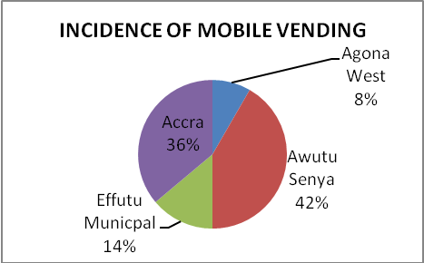
Children working as mobile vendors/ hawkers were found in all four districts of the study. Children typically sold pure water, food (banku, doughnuts, fruit), phone credit, items such as sandals, earrings etc, at markets, vehicle checkpoints and lorry stations.
It is difficult to calculate the per-day wage since the amount of money earned is largely dependent on the item sold. However, children made anywhere between Ghc 0.3 ($0.15) and Ghc 20 ($10) per day as mobile-vendors. (Graph 14 – Incidence of mobile vending, CWPC study)
Children worked anywhere between 3 and 17 hours per day. Almost all the children reported fatigue due to being continuously on their feet. Children also spoke about how they had friends who had been killed or severely injured by moving vehicles in this work. Most of the respondents also complained about being cheated by customers in moving vehicles.

STATIONARY VENDORS
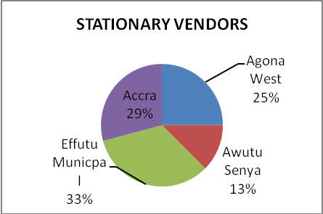
Around 17% of the sample was stationary vendors from all four districts of the study. Children typically manned stalls or small shops selling food, provisions and other items in markets, schools, lorry stations and other public places. These children usually made less money than mobile vendors. The average earnings reported by these children was around Ghc 6.3 ($3.15) per day. Children spent 6 hours on an average, engaged in this work.
(Graph 15 – Incidence of stationary vending, CWPC study)
Around 7.1% of these children were in school. 14.2% of the respondents were helping their parents/others and reported not retaining earnings from this work.
The problems faced by these children include fatigue, people stealing their goods and ill-treatment from their employers.

DRIVERS’ MATE
A few children in the sample, all boys, worked as drivers’ mates, all at Kaneshie, Accra. In this job, the boys are assistants to taxi/tro-tro drivers and are required to entice prospective passengers, collect payment and load the luggage into the vehicles, among other things.
This job involves longer hours compared to other jobs since the boy is required to be with the driver throughout his day’s work; all the respondents reported 12 hours or longer as the time spent working in a day.
The per-day wage is Ghc 12.5 ($6.25). The biggest problem faced by children in this work is the high probability of not being paid for the day if the car/vehicle broke down. Around half the boys also reported ill-treatment by the car/vehicle driver.

OTHER SECTORS
Since there were too few respondents from the rest of the sectors in Graph 7, it is difficult to get an accurate picture of the nature of work in these sectors. Nonetheless, an attempt has been made in the table below to present the available information; the reader is however requested to bear in mind that these may be isolated examples.
S. No | Sector | % of respondents in sample | Work Undertaken | Average wage/ day (Ghc) | Average wage/ day ($) | Hardships Reported | Remarks (if any)
 | Unskilled Labourers | 8% | Fetching water, Carrying Firewood & Blocks, Milling Corn | 14.1 | 7.05 | Fatigue, Ill-treatment by employer
 | Fishing Labourer | 3% | Mending nets, collecting fish from nets, fishing in the sea | 4.4 | 2.2 | Illnesses due to nature of work | Only 1 respondent reported any hardship. All respondents reported relatively low pay compared to other jobs
 | Prostitution | 1% |  | 1 | 0.5 | Ill-treatment by the client | The wage per day seems to be low. Respondents engaged in prostitution said that they preferred non-Ghanaian customers but were otherwise hesitant to talk about their work.
 | Preaching | 1% | Preach to passengers in cars/vehicles, on the street | 8.5-50 | 4.25-25 | Ill-treatment by people
 | Salaried Worker | 1% | Factory Worker | 6 | 3 | Ill-treatment by employer
 | Other skilled labourer | 2% | Hairdressing/ Masonry | 5 | 2.5 | Fatigue
(Table 18 – Summary of child labour in other sectors, CWPC study)

NETWORKING & EMPOWERMENT
Questions on networking and empowerment such as presence of trusted people outside their homes, support that can be expected from them in case of need for food/shelter/financial aid, frequency of interaction with these people, other institutional assistance received if any, etc. were posed to the respondents. The results are summarized below:
Around 45.7% of the respondents reported that there were no people they trust outside their homes. The summary of responses from the remainder of the sample is indicated below:
Data on Networking
 | Only one trusted person outside the home | 9.23%
 | Two trusted people outside the home | 8.67%
 | Three or more trusted people outside the home | 36.15%
(Table 19 – Data on children’s networks, CWPC study)
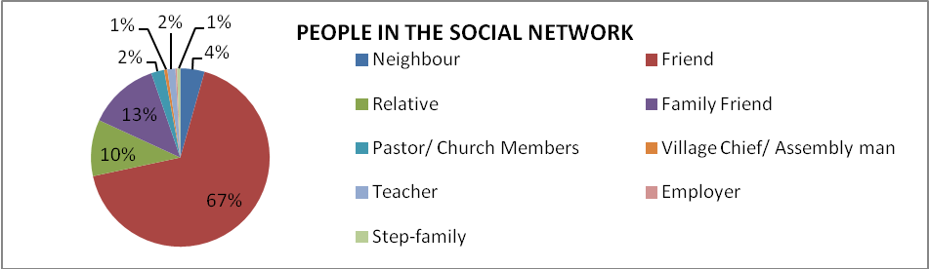
Data was also collected on the relation of the respondent with the people in their network. This is shown below:
(Graph 16 – Relationship with people in social networks, CWPC study)
Friends and relatives comprised of a major portion of the social network. Unexpectedly, some children knew their village chiefs and assembly men and went to them for help. Pastors, teachers, employers and step-families consisted of a small portion of the network. The frequency of interaction with the people in the network is shown in the cross-tabulation below:
Count of F3_Last_Meeting  _Days_Person1 | Column Labels
Row Labels | In the last one week/ weekly | In the last one month/ monthly | In the last 3 months/ quarterly | In the last 6 months/ half-yearly | In the last year/ annually | 1-5 years ago | More than 5 years ago | Grand Total
Employer | 1 |  |  |  |  |  |  | 1
Family Friend | 40 | 1 |  |  | 2 |  | 1 | 44
Friend | 199 | 13 | 7 | 2 | 5 | 3 | 1 | 230
Neighbour | 11 | 2 |  |  | 1 | 1 |  | 15
Pastor/Church Member | 8 |  |  |  |  |  |  | 8
Relative | 30 | 1 | 1 |  | 1 | 1 | 1 | 35
Step-Family | 2 |  |  |  |  |  |  | 2
Teacher | 5 |  |  |  |  |  |  | 5
Village Chief/ leader | 2 |  |  |  |  |  |  | 2
Grand Total | 298 | 17 | 8 | 2 | 9 | 5 | 3 | 342
(Table 20 – Cross-tab, social networks, Frequency of interaction, CWPC study)
Questions were also posed on the type of assistance that could be expected from people in these networks. The responses are summarized in the pivot table below:
Count of Food & Shelter | Column Labels
Row Labels | Will provide food & shelter | Will provide food only | Will not provide food or shelter | Grand Total
Employer | 1 |  |  | 1
Family Friend | 37 |  | 7 | 44
Friend | 194 | 16 | 20 | 230
Neighbour | 12 |  | 2 | 14
Pastor/Church Member | 5 |  | 3 | 8
Relative | 35 |  |  | 35
Step-Family | 2 |  |  | 2
Teacher | 5 |  |  | 5
Village Chief/ leader | 1 |  | 1 | 2
Grand Total | 292 | 16 | 33 | 341
(Table 21a – Social Networks, Assistance Provided, Food & Shelter, CWPC study)
More than 90% of the people in the social networks are willing to provide food and/or shelter when necessary. An important point here to note is that friends comprise a substantial portion of the food/shelter providers.
Correspondingly, around 75% of the people in the network can be expected to provide financial aid, if necessary. It is also important to note that 12% of the people are willing to provide financial help as a loan only.
Count of Financial Assistance | Financial Assistance
Row Labels | Yes | No | As loan only | Grand Total
Employer |  |  | 1 | 1
Family Friend | 32 | 10 | 2 | 44
Friend | 167 | 27 | 36 | 230
Neighbour | 13 | 1 |  | 14
Pastor/Church Member | 4 | 4 |  | 8
Relative | 31 | 2 | 2 | 35
Step-Family | 2 |  |  | 2
Teacher | 5 |  |  | 5
Village Chief/ leader | 1 | 1 |  | 2
Grand Total | 255 | 45 | 41 | 341
(Table 21b – Social Networks, Assistance Provided, Food & Shelter, CWPC study)

INSTITUTIONAL ASSISTANCE
The study encountered children from all four districts who were recipients of institutional assistance/aid but these comprised only around 2.6% of the sample. In most cases, children received books, uniforms and school supplies usually from the Government of Ghana. In Kaneshie, an isolated example of a child being taught for free by an organization was found. The table below gives the details of institutional assistance received by the children in the sample
 | Children receiving books, uniforms and supplies from the Government. | Children receiving money from the Government. | Children receiving free education (non-Government)
Agona West | 4
Awutu Senya |  | 1
Effutu Municipal | 1
Kaneshie |  |  | 1
Total | 5 | 1 | 1
(Table 22 – Institutional Assistance, CWPC study)

AWARENESS ON CHILD RIGHTS
The respondents were also asked about child rights. Children were asked to talk about all the rights they think every child should enjoy. Only around 35% of the respondents were able to mention any child rights. The rights mentioned by the children are shown below:
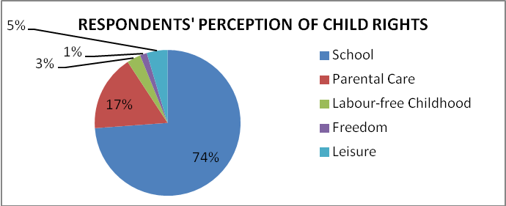

(Graph 17 – Children’s Perception of Child Rights, CWPC study)

FOOD & SOCIAL SECURITY
Food security is a major indicator of parental care. More than a third of the sample reported food insecurity. This is briefly described in the table below:
Data on Food Security
 | Percentage of children who skipped at least one meal in the week before the interview due to lack of food. | 36.15%
 | Percentage of children who had to go without food for an entire day in the week before the interview due to lack of food. | 15%
 | Percentage of children who reported not having enough food to eat in their day-to-day lives. | 25.7%
(Table 23 – Food Security Data, CWPC study)
However, in this context, data on food security should be assessed in the backdrop of how the food security is achieved. Around 14% of the respondents were their own sole bread-winners. 37% (overall figures) of the children were found to use their own earnings to buy food
“Hunger is painful” says a 14-year old boy from Kaneshie. “I therefore eat any food I can find and pray that it is safe”.
The boy carries loads at Kaneshie Station for a living. He has no parents and lives on the street.
Around 95% of the children interviewed said that they would never accept food from a stranger; the most commonly ventured reason was that the food may be poisoned or drugged. 5% of the children said that they would accept food from anyone.
Along with food security, questions were administered on the availability of adequate and safe shelter for children. Around 11.5% of the sample reported that they do not always have a place to sleep. Around a quarter of the sample stated that they have slept in places that felt unsafe.

This is indicated the pivot table below, detailing the locations that children slept, but felt unsafe:
 | Column Labels
Row Labels | Accra | Agona West | Awutu Senya | Effutu Municipal | Grand Total
Farm |  | 1 |  |  | 1
Friend's house |  | 1 | 5 | 5 | 11
Respondent' house |  | 7 | 3 |  | 10
Relative's house |  | 1 | 2 | 2 | 5
School |  |  | 1 |  | 1
Seashore |  |  |  | 1 | 1
Shop/Street | 16 | 4 | 5 | 6 | 31
Grand Total | 16 | 14 | 16 | 14 | 60
(Table 24 – Unsafe Shelter, CWPC study)
It can be seen that children often felt unsafe in their own homes. This is mainly due to the condition of the homes – respondents ventured the information that they were afraid their houses would collapse on them. 4% of the children said that they would not mind seeking shelter with strangers.
Around 8% of the respondents stated that they suffered physical abuse in the month prior to the survey. In around a third of these cases, the abuser was from within the respondent’s family (parents and siblings). The reasons for and details of the abuse were also collected. Children were usually belted or hit with sticks, cutlasses or stones. Around 20% of the abuse cases were due to extortion of money (when the child refuses to give up the money he/she earned). The children were abused about once a month, on an average, with two being the maximum number of times per month sample.
“My father and step-mother often hit me” says a 9-year old girl from Fetteh. ”My father beats me with a chain and my step-mother uses a cutlass. She also bites me. I don’t know why”.
The girl’s parents are divorced and her mother suffers from a mental condition. This child has never been to school and is the fourth child of five children. She also suffers very high food insecurity and often sleeps on the street.
The above data on abuse pertained to only a month prior to the survey. More generally, 26.7% of the children said that there were people around them who physically abuse them.
Girls in Kaneshie spoke fearfully about gangs of boys who were known to rape women and girls. Boys spoke about fearing armed robbers and many reported being harassed by local thugs to give up their daily wages.
Children were also asked questions on their recourse if they encounter a friend being abused. 66.1% of the children were able to identify people who they could call upon to help their friends. This is shown in the graph below (all responses included):
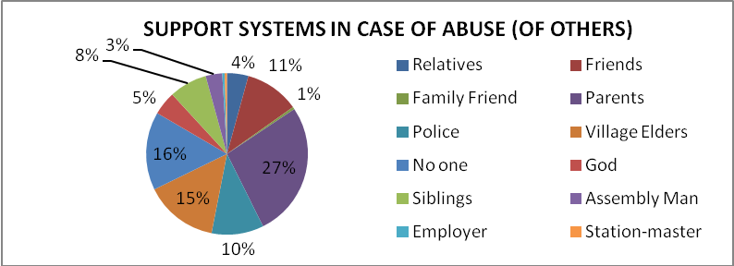
(Graph 18 – Support Systems for Abuse, CWPC study)

HAPPY & SAD EVENTS
In order to understand the situations children have been through and their backgrounds, a number of questions were administered on life-events and happy and sad occasions.
For the average child, happy events consisted of games, holidays and celebrations. Some of the responses are more telling though and many children wistfully remembered the happier days of their lives; a few of such responses are shown below:
S. No | Happy Event/ times
1. | When they used to stay with their parents/loved ones and had people to care for them
2. | When their parents’ business/work was doing well and they were able to afford a good life
3. | When they were going to school
4. | Their family escaped a war
5. | When they used to live at their hometowns/villages and had plenty of support from people
6. | Their parent/sibling had a narrow escape from death.
7. | People helping them in times of hunger
(Table 25a –Happy Events, CWPC study)
Children were also asked to relate the three saddest events/days of their lives; the responses are indicated below:
S. No | Sad Event/Times
 | Death of parents/siblings/loved ones
 | Having to drop out of school due to lack of money
 | Hunger times; they were hungry for days without food
 | Being separated from their parents/loved ones
 | Losing money/being robbed
 | Their parents/loved ones being insulted or harmed by others
 | Divorce of parents
 | Being insulted/beaten by others
(Table 25b –Unhappy Events, CWPC study)

SCARY THOUGHTS
Children were also asked if there were any thoughts that scared them. This was asked to get an idea of the risks/dangers children knew they were facing. The answers were quite informative and a few of the most commonly mentioned thoughts are given in the table below:
S. No | Scary Thoughts
 | The thought of stealing
 | The thought of never going to school again
 | Not being able to repay debts
 | Judgment day
 | The thought of getting a boyfriend just for the money it will bring
 | Their current way of life
 | Being sent to work at the farm
(Table 25s –Scary Thoughts, CWPC study)

PARTICIPATORY EXERCISES
In addition to the surveys, Focus Group Discussions (FGDs) and participatory exercises were conducted separately with groups of children and groups of parents/guardians to understand the community perception on child rights, child care, children’s issues and potential solutions. The exercises and their findings are briefly described below:

STORY TELLING
A short story-telling exercise was done with groups of children to understand their perceptions on parental care and the risks in losing parental care.
The exercise was done with gender-balanced groups of 6-10 children between the ages of 8-17 years in select communities. To each of these groups, the moderator told a short story about a hypothetical child who was about to lose parental care. The child in the story does not have a mother and the father is about to leave home for good in search of work. The children were then asked to discuss the problems and risks the child in the story could face. The stories were tailored according to the communities to make them as relatable as possible.
The discussion was moderated and every child was given ample time to express their opinions. The moderator had a list of follow-up questions to engage children in the possible risks and consequences.
The findings of the exercise are briefly summarized below. The group was asked to discuss, debate and decide the likely risks that the child in the story would face. The groups chose to discuss separately the situation of male and female children, who could be the child in the story, rather than speaking of a child generally.

This is indicated below:
Risks Faced by the Child in the Story Who Is About to Lose Parental Care
Risks likely to be faced by a male child (arranged by frequency). |  | Risks likely to be faced by a female child (arranged by frequency).
 | The child would have to drop out of school and engage in child labour |  | The child would have to drop out of school and be forced into prostitution
 | The child is likely to die soon because no one would care for him |  | Pregnancy, still-births and STDs
 | The child will become a thief or will become heavily debt-laden |  | Have many children with multiple people due to the situation
 | The child is likely to become a beggar or a tramp |  | Is likely to become a thief
(Table 26 – Potential Risks Faced by a Child about to Lose Parental Care, CWPC study)
It is interesting to note that none of the focus groups mentioned the threat of child trafficking as a potential risk. The above exercise was conducted in the communities of Abodom and Kumasi, both which are believed to be source hubs for trafficking of children. During the course of the structured interviews, on multiple occasions, the research team encountered children mistaking them for traffickers and inquiring when and where they would be taken away. They had no questions about who the research team were, what work they would be required to do, where they were to be taken to or what they would be paid. In all of these cases, the children presented themselves voluntarily and seemed wholly willing to be taken away for work. It is indeed possible that they do not see trafficking as a risk to their well-being.
After the discussion on the potential risks likely to be faced by the child in the story, the group was asked to talk about the possible recourses available to the child and suggest solutions to him or her. The summary of the discussion is given below:
Recourse/Coping Solutions for the Child about to Lose Parental Care
Possible recourse options for a male child (arranged by frequency). |  | Possible recourse for a female child (arranged by frequency).
 | Request others for help. Ask for help from elders (parents of friends) and teachers |  | Ask only trusted people for help. Be wary of people who murder and rape
 | Run errands for people in the hopes of getting themselves taken in by a family |  | Run errands and earn money. Do not leave the village for jobs
 | Do not give in to the pressure to steal |  | Do not snatch husbands, turn to prostitution or give in to pressure and steal
 | Start learning a trade to build skills |  | Start learning a trade to build skills
(Table 27 – Potential Solutions for a Child about to Lose Parental Care, CWPC study)
The groups were of the strong opinion that the child in the story cannot continue schooling. All recourse suggested was aimed at ensuring that the child survives. It is note-worthy that the girl child is advised to not leave the village for employment, despite many children making this choice for themselves. The reasoning behind this advice was that threats will increase since the child will receive little or no support from elders outside the village. The groups also expressed that being taken in by a family is only an option for male children.
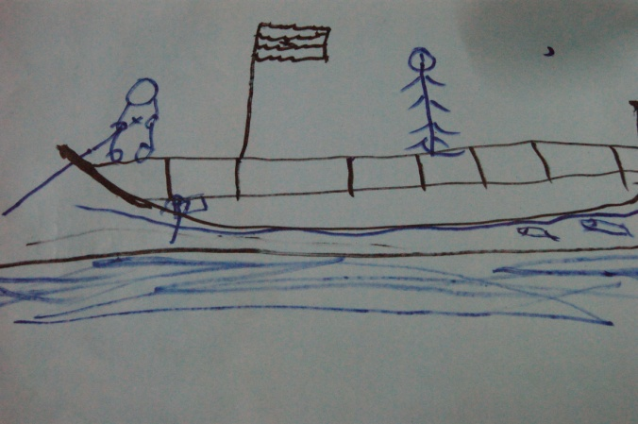
The groups were then asked to discuss about conflict resolutions in families in general, with inputs on how conflicts are resolved in their homes. Specifically, they were asked to discuss if the child in the story can prevent their father from leaving him or her. 44% of the first group and 50% of the second group opined the child in the story can try to trick their father into staying back and not leaving them. (Fig 2 - “The world I do not want”, CWPC Study)
The remainder of the groups said that children can have no say in any issues and it is entirely the parents’ decision. No child in any of the groups thought that conflicts can be resolved through discussions. The groups spoke about their own homes where the parents’ word was law and their opinions were rarely taken into consideration. It was therefore difficult for the groups to fathom the idea of conflict-resolution.
The groups were also asked to talk about children facing similar situations in their communities and the reasons for their loss of parental care. The summary of the discussion is indicated below:
Perceived Reasons for Children Losing Parental Care
(Arranged by frequency)
1. | Conflicts in marriages lead to divorce
2. | Fathers abandon children and leave homes for jobs
3. | Parents abandon children due to financial constraints
4. | Illnesses cause deaths of parents
(Table 28 – Common Causes for Lack of Parental Care, CWPC study)
The final discussion topic for the groups was Child Rights. The groups were asked to discuss the meaning of rights and debate on the rights all children should be entitled to.
 | Definition of Child Rights | Right Identified
Group I | Rights are what every child in the world should have, without exceptions. | Freedom, Food and Education
Group II | Rights are privileges that every child should be able to enjoy throughout their childhood. | Food, Clothing, Shelter, Education, Parental Care
(Table 29 – Children’s Perception of Their Rights, CWPC study)
These exercises were done with only one group each in two communities since it turned out to be a very emotional experience for most children. Many of the children in the groups could relate to the child in the story and in five cases, the children said that the child in the story could be them. On two occasions, the exercise had to be aborted since the children in the groups found themselves in tears and wanted to leave the discussion. The moderators then engaged the children in drawing and games to ensure that they did not leave the group while still distressed.

INSTITUTIONAL RANKING
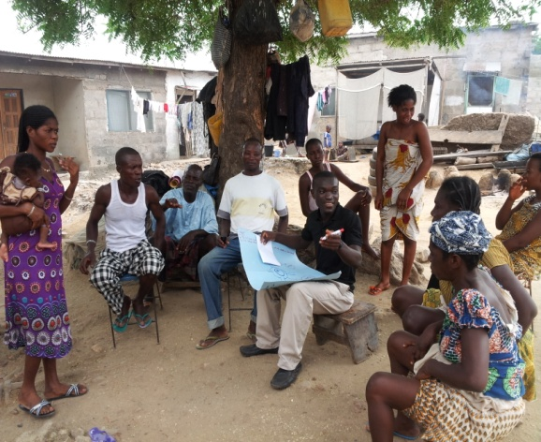
An institutional ranking exercise was conducted with groups of parents/guardians of children who met the sampling criteria in select communities to understand the existing pro-poor interventions and how effective they have been. Gender-balanced, diverse groups of 6-8 adults were chosen in every community and each group was asked to list all the pro-poor interventions (the groups were first asked to talk about all the organizations/programs in the village and the pro-poor interventions were listed through follow-up questions) in their village. (Fig 3 – Institutional Ranking Exercise, CWPC Study)

A Chapati diagram was then drawn by the moderator for the institutions in each community, based on the following:
- Ranking of the institutions in the order of importance for the community by the group.
- Ranking of institutions by accessibility.
Follow up questions were asked on how each of the institutions helped the communities, how each of these organisations could serve the village/town better, what were the strengths and weaknesses of each institutions and if there were any needs that were not being met by these organisations. The results of this exercise is summarised below.
    - ABODOM (AGONA WEST)
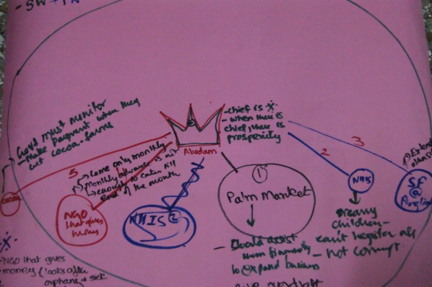
Abodom community in the Agona West district was found to have the most pro-poor interventions of all the communities visited. Unfortunately, nobody in the community (including people at the village chief’s palace) was able to name most of the organizations. The results of the exercise in Abodom are summarized below:
(Fig 4 – Chapati Diagram, CWPC Study)

S.No | Name of the Program/ Institution | Ranking  (Importance) | Ranking  (Accessibility) | Remarks
 | An organization that comes to buy palm from the farmers | 1 | 1 | - This organization has helped the community greatly  - The services should be expanded to include financial assistance to expand business and overdraft facility  - This organization is slightly corrupt
 | Un-identified NGO | 2 | 4 | - The NGO gives money to orphans and sick children  - They visit the community every month. This is not sufficient because the money received does not last till the end of the month
 | An organisation that cuts off old cocoa trees and gives seedlings and money to farmers for cultivating cocoa. | 3 | 5 | - The Government must monitor this organization to ensure that they pay the farmers when they cut old cocoa trees
4. | School feeding program | 4 | 3 | - The program is available only at Anglican school. Therefore all children are not able to register for this program  - It should be expanded to other schools
 | National Health Insurance Scheme (NHIS) | 5 | 2 | - Registration for this program is difficult  - It is corrupt
(Table 30 – Institutional Ranking, Abodom, CWPC study)

    - KWENDRUM (EFFUTU MUNICIPAL)
Kwendrum presented a unique challenge since the groups seemed to be totally unaware of any pro-poor institutions/organisations and the research team had to try the exercise with multiple groups. Challenging Heights is also operational in Kwendrum but the people in the groups did not seem to be aware of its services, despite various attempts by the moderator of the exercise to invoke a recall. This is interesting since Challenging Heights has undertaken more than 40 programs in the community. However, this is typical of most programs/interventions; beneficiaries often do not know the names of the programs unless the promotion actively includes methods to aid recall. The results of the Institutional Ranking exercise in Kwendrum are summarized below:

S.No | Name of the Program | Ranking  (Importance) | Ranking  (Accessibility) | Remarks
 | Free Education (public schools) | 1 | 1 | - There is a lot of corruption  - The quality of teaching is very poor
 | National Health Insurance Scheme (NHIS) | 2 | 2 | - The program is not free and not easily accessible
(Table 31 – Institutional Ranking, Kwendrum, CWPC study)
    - KYENKYESO (AWUTU SENYA)
The results from Kyenkyeso in Awutu Senya district are summarised below. Despite Challenging Heights being operational in this community, complete with Community Child Protection Committee (CCPC) support, the people in the groups were not aware of the organisation’s presence or its activities.
S.No | Name of the Program | Ranking  (Importance) | Ranking  (Accessibility) | Remarks
 | National Health Insurance Scheme (NHIS) | 1 | 1 | - It is corrupt
 | CCI | 2 | 2 | - The program is meant to provide credit but it is not very accessible
(Table 32 – Institutional Ranking, Kyenkyeso, CWPC study)
    - FETTEH (EFFUTU MUNICIPAL)
In Fetteh, there were only 2 pro-poor institutions/programs identified. The results of the exercise are summarised below:
S.No | Name of the Program | Ranking  (Importance) | Ranking  (Accessibility) | Remarks
 | National Health Insurance Scheme (NHIS) | 1 | 1 | - The program covers only certain illnesses  - The officials administering the program are very corrupt  - The program is expensive since people are required to pay first to be reimbursed. There have been many instances where children have died due to treatment refusal.
 | National Youth Employment Program (NYEP) | 2 | 2 | - This program benefits only the youth  - It will be helpful if this program covers children who are out of school, in addition to youth
(Table 33 – Institutional Ranking, Fetteh, CWPC study)

PROBLEM RANKING
A problem-ranking exercise was also conducted with the groups of parents/guardians of children who met the sampling criteria. This was a general exercise; the main aim was to assess the importance of problems faced by the children in their parents’ estimation. The exercise also gives us a glimpse into issues faced by people and the children in the communities. The findings from the exercise are given below:
    - KWENDRUM
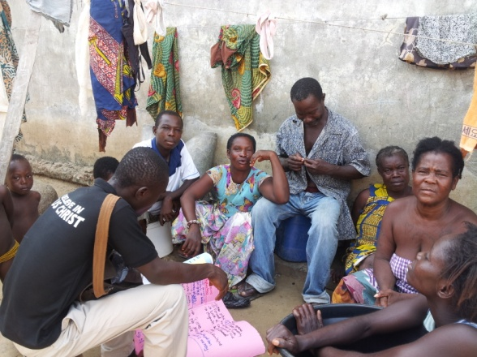
Almost all the people in the groups at Kwendrum, Effutu Municipal district had reasonably serious health issues such as elephantiasis, paralysis, strokes etc. A very note-worthy point is that the people at Kwendrum did not see child-trafficking as an offence/problem. The groups freely spoke about how the community solves some of its monetary issues by selling children and sending them away for work. The adults opined that children are better-off working and earning their living elsewhere rather than staying at home and doing nothing. (Fig 5–Group Exercises at Kwendrum, CWPC Study)
The parents/guardians in each group were asked to first individually state their problems, rank them and then discuss the problems of their community. While the individual problems of the parents are less relevant for this report, it should be mentioned that no men and only 40% of the women spoke about the inadequate parental care rendered to their children despite the fact that all the parents in the groups were not sending their children/wards to school. While discussing problems of the community, lack of schooling for children was ranked last.
S. No | Problem | Number of parents/guardians who raised/faced this issue in the Individual Ranking exercise | Rank awarded by the group
1. | No job opportunities in the community. Everyone is forced to fish as a result | 3 | 1
2. | Lack of capital/credit facilities to escape poverty | 1 | 2
3. | Distress migration by people to Accra | 1 | 3
4. | Almost everyone suffers from severe health issues | 7 | 4
5. | Very few people are able to send children to school | 2 | 5
(Table 34 – Community Problems Ranking, Kwendrum, CWPC study)

    - ABODOM
In the community of Abodom, Agona West district, 2/3^{rds} of the women and 50% of the men in the groups spoke about lack of children’s schooling as one of their problems during the individual problem ranking exercise. None of the group members were sending their children to school. The results of the community problem ranking exercise are given below:
S.No | Problem | Number of parents/ guardians who raised/ faced this issue in the Individual Ranking exercise | Rank awarded by the group
1. | No paramount chief in the community for the last 15 years | 0 | 1
2. | No Senior High Secondary School in the community | 1 | 2
3. | No ready market to sell farm produce | 2 | 3
4. | No credit facilities | 2 | 4
5. | No employment opportunities | 2 | 5
(Table 35 – Community Problems Ranking, Abodom, CWPC study)
    - FETTEH
The community of Fetteh in Effutu Municipal is reported to have high levels of school-dropouts, which when combined with the trafficking that is alleged to be rampant, makes it deserving of pro-children interventions. During the course of fieldwork, the research team encountered many cases of child-trafficking, which were reported to Challenging Heights for action. However, unlike in Kwendrum (refer Sec 5.3.1), the people at Fetteh recognise child trafficking as a problem, as shown below.
In the individual problem ranking exercise, all the women in the groups and around 33% of the men spoke about their children not being in school (none of the children/wards of the people in the groups were in school). The summary of the community problems ranking exercise is given below:
S.No | Problem | Number of parents/guardians who raised/faced this issue in the Individual Ranking exercise | Rank awarded by the group
1. | No market; the nearest good market is in Agona, Swedru | 0 | 1
2. | No employment opportunities, people are required to migrate to Accra/other places for work | 4 | 2
3. | There is no work even after schooling. Small girls and educated girls get pregnant for money | 0 | 3
4. | Children are trafficked to Yeji/Lake Volta since parents are unable to fend for them. | 0 | 4
(Table 36 – Community Problems Ranking, Fetteh, CWPC study)
    - KUMASI (Awutu Senya District)
Like Kwendrum and Fetteh, Kumasi is also a fishing community which is in the Awutu Senya district. During the time of this study, Challenging Heights had instituted a Community Child Protection Committee at Kumasi for the protection of children. 80% of the women and no men in the groups spoke about their children receiving inadequate parental care, although by design, all the children/ wards of the people in the group qualified under at least one of the indicators as receiving insufficient care. The summary of the community problems ranking exercise is given below:
S.No | Problem | Number of parents/guardians who raised/faced this issue in the Individual Ranking exercise | Rank awarded by the group
1. | Need public toilets | 0 | 1
2. | No dumping site for refuse | 0 | 2
3. | No market or employment opportunities | 5 | 3
4. | Water problems | 0 | 4
(Table 37 – Community Problems Ranking, Fetteh, CWPC study)

CHILD RIGHTS & CONFLICT RESOLUTION
Groups of parents/guardians were asked to discuss child rights; specifically the rights they were promoting/wanted to promote for their children or wards. All the groups seemed uniformly dispassionate about the subject and did not think that rights were particularly important in children’s lives. The rights mentioned by the groups are given below:
S. No | Child Rights | No: of groups that  acknowledged the right
1. | Right to education | 3
2. | Parental Care | 3
3. | Freedom | 1
(Table 38 – Parents’ Perception of Child Rights, CWPC study)
Parents also spoke about how conflicts are resolves in their families, specifically conflicts with children. Interestingly, none of the groups recognised the concept of conflicts; any difference of opinion with children apparently would be usually resolved by force. The summary of the discussion is given below:
S. No | Conflict Resolution Methods | No: of groups that subscribed to the method
1. | Advise the children | 2
2. | Physical coercion | 2
3. | Send the children away as punishment | 1
(Table 39 – Conflict Resolution with Children, CWPC study)

STAKEHOLDER INSIGHTS
As part of the study, the research team interviewed key officials of the Ghanaian Government and relevant stakeholders to get their input on the issues of child labour and child trafficking prevalent in the study areas. However, these interviews were not as informative as hoped and none of the officials/departments was able to give a strategic view of the problems and potential solutions nor the much-required estimate of the number of children without parental care in the areas under their jurisdiction.

DOVVSU
The DOVVSU (Domestic Violence and Victim Support Unit, Ghana Police) is required to handle all the child abuse and trafficking issues within its jurisdiction. DOVVSU officials in Winneba (Effutu Municipal district) saw poverty and irresponsible parenting as the root cause of these issues.
“The biggest intervention that can be done is to set an example by punishing offenders” maintains the Inspector at DOVVSU, Winneba. “When people see others getting punished, it will serve as an effective deterrent”.
In late December 2007, a couple was arrested for child trafficking in Winneba. The woman served a short time in prison but the man is reported to be still serving his sentence.
“It was a second degree felony. This incident attracted a lot of attention” says the Inspector, DOVVSU, Winneba. “People began to be afraid of meeting with a similar fate”.
The Unit voiced that they are limited by funding and resources. According to the officials, the Unit would be more effective if made mobile for patrolling and if they were provided with facilities to shelter victims when necessary.
The officials at Winneba explained that very few cases of child abuse cases get reported and come to light. This is contrary to the situation at the DOVVSU unit in Swedru, Agona West district. “There are less cases of trafficking in our area but 40-50 cases of parental neglect/ abuse come to us everyday” declare the officials at Swedru. “Child labour is very common in farms. Poverty and lack of family planning are the chief cause of these issues”.
Like in Winneba, the DOVVSU Unit at Swedru feel the need for resources to become more effective. “Sometimes, people and children walk miles to report cases to us and get too tired to walk back” reveal the officials. “It is very difficult for them. It will be useful to have vehicles and other resources at times like these”.
The main function of the Unit is to deal with domestic disputes and child abuse issues. They are required to investigate the problems, settle disputes if possible and arrest the offenders when necessary. The Unit also undertakes periodic community sensitization programs through different channels to deal with the problem at the source.

Department of Social Welfare (DSW)
The Department of Social Welfare (DSW), Government of Ghana is required to undertake child rights promotion, community care and justice administration. It works in collaboration with the DOVVSU. Every district in Ghana has a DSW office which looks after the affairs of the district, although many of the districts have only one staff member in the office.
The DSW does community sensitisation programs (undertakes screening of films, puts up billboards, does counselling sessions) against child labour. Like the DOVVSU, the officials at DSW in Winneba and Swedru maintain that action against offenders is the biggest deterrent. The DSW is also tasked with rescuing children from any sort of abuse.
“We once paid a surprise visit to vehicle checkpoints (which are hubs for hawkers) and arrested all the children who were found working during school-hours” reported a DSW officer in Swedru. “Their parents had come to our office, explain why they were not in school and pay a fine to have them released. It was very effective and the number of working children dropped drastically. We try to do this every quarter”.
“Agona West has mainly a farm-based economy. People do not have credit facilities/capital for work or the money to engage labour. Hence, the children are used for farming” says a DSW official at Swedru. “They need a lot of education and counselling on this issue”.
Child-trafficking is reported to be widely-prevalent in Winneba but hardly any cases come to the DSW (In the year 2011-2012, only 5 trafficking cases were reported). “The problem is actually more than that” say the officials at DSW, Winneba. ”The people do not see child labour/trafficking as an offence. They think that since it is their child, they can do what they please. They do not see why the government should interfere”.
Despite education being free, there are still many cases of people not sending their children to school. “The problem is also with the system” explain the DSW officials at Winneba. “Schooling is free from Class 1 to JHS Form 3. Pre-school is not free. Children at pre-school learn the alphabet and numbers. Many people cannot afford this. Therefore, their children find it very difficult when they join (free) school and drop out as a consequence. The system and the people both are required to change if we are to achieve our mission of protection of child rights”.

RECOMMENDATIONS & CONCLUSION
Several aspects – social, cultural and economic come to light from the study findings. It is therefore imperative for a comprehensive discussion on why the present circumstances persist and potential solutions.

DISCUSSION – LACK OF PARENTAL CARE
From the data, a few key insights into the causes of inadequate parental care are presented below:

Lack of involvement from fathers
Both the survey data and the participatory exercises suggest that fathers play a smaller role in their children’s welfare (almost twice the number of children in the sample, who by design met indicators of lacking parental care, see their fathers everyday compared to their mothers, and only around 20% of the men in all group discussions spoke about their children’s issues while discussing their problems). Data from the qualitative questions also suggest that children look primarily to their mothers to have their basic needs met.
A possible explanation could lie in the cultural entrenchment of the belief that children belong to their mothers and therefore fathers assume little or no responsibility. Challenging Heights currently undertakes advocacy programs to bring about a change in the mind-set of men, has also promoted laws and enforcement of laws that force fathers to assume more responsibility. In the past, the organisation undertook programs to provide seed money to fathers of children to start small business and increase household income, but later switched to only providing the seed money to mothers due to the fathers not using their profits to better the lives of their children. Community awareness programs on parental responsibility are also routinely conducted involving fathers to spread the message. Nonetheless, this continues to be one of the roots of the problem and needs to be addressed.

Family size
On an average, each respondent had 6 siblings (discounting step-brothers and sisters). The largest number of children any family had in the study was 14. As a consequence, parents are often unable to meet the needs of everyone in the household which drives children towards labour or results in them abandoned or trafficked. During the course of the fieldwork, respondents often spoke about a select few children (usually boys) in their homes being sent to school.
Large family size also finds its roots in the cultural beliefs of the people. Traditionally, any woman who produces ten children (a concept known as bedugwan) is facilitated and celebrated. Relatives also take pride in children being named after them and this affects pressure on women to have more children. In the study areas, the research team came across two cases of women who were aiming to have ten children, despite the fact that their existing children did not receive adequate care. Parents also tend to look at children as earning hands for the family and care-takers in their old-age.
Discussions with the stakeholders (Department of Social Welfare and DOVVSU) suggest that family planning is not a topic that is usually well-received in the communities. The officials spoke at length about how most women refuse to even listen to the message, let alone practice it. A few officials also revealed that they feel threatened by the response of the communities to programs on family planning. Therefore, while there is a need to address large family size when addressing the issue of children without parental care, a change in cultural attitude is needed before emphasize on family planning methods could be effective.

Lack of education
Very few parents recognized schooling as a means to development, although many of the out of school children did recognize this benefit. Although in theory, parents agreed that children should be in school, it was observed during fieldwork that it is seldom put into practice. The oft-quoted reason by parents/guardians was that the benefits of schooling would only been realized after years and that schooling was expensive. Despite the free education scheme of the Government of Ghana, parents found schooling prohibitively expensive since they could not afford school supplies, money for food and various other costs like fees for exams and parent teacher associations. Children therefore had to forgo school.
Importantly, 90% of the school-dropout children wanted to go back to school. Programs involving free/subsidized education along with mid-day meals could go a long way in ensuring children remain in schools. Systems to ensure that the schools’ capitation grant arrives on time and long-term plans for children to get all they need for schooling should be put in place.

Need for awareness
There is liberal evidence (from the institutional ranking exercises) that people are barely aware of the available programs and organizations in their communities. Only one community (Abodom) was able to talk articulately about the different programs available to the people. Therefore, creation of avenues for awareness of what opportunities/help is available is vital in ensuring that the benefit is reaching people that actually need it.

Poverty
Poverty is a part of most development problems. In this context, poverty of parents translates directly into poverty of their children. Lack of financial security drives children to drop out of school and into labour and pushes parents into trafficking children. Challenging Heights undertakes programs to increase the disposable income of needy families by providing linkages to micro-credit and seed money for businesses. Provision of systems for food security and adequate shelter need to be examined in order to further alleviate these problems.

Inadequate Law Enforcement
Law enforcement would be another milestone towards protection and promotion of child rights. According to the concerned government officials (from DSW and DOVVSU), very few trafficking, child abuse and neglect cases are reported and fewer get addressed satisfactorily. Although the required laws seem to be in place, their enforcement seems woefully inadequate. In the short-term, conflict resolution avenues can be deployed in the communities to address child-related domestic disputes and cases of neglect. Advocacy is required to get the government to take more responsibility towards child protection. NGOs and development organizations should lobby for enforcement of good policies.

Community perception on child rights
Apart from these issues that face children, it is also imperative to talk about community perceptions on child rights, child labour and trafficking. During the course of the interview, the team encountered many parents/guardians who spoke about the children they have sold/trafficked. Some parents even requested the research team to take their children away. Despite there being numerous laws on the protection of child rights, the communities fail to see these as legitimate instruments to protect their children. Sensitization programs that address the above issues can also encourage extended family care, which is currently going out of practice in the study communities, but in its true form can be a very healthy alternative for children.

Reuniting migrant children with their families
Children who were forced to leave their homes, voluntarily or otherwise, to fend for themselves would benefit from being reunited with their families, provided that they receive adequate care and are able to attend school. Challenging Heights currently undertakes rescue operations that involve bringing trafficked children back from the Volta Lake and other fishing regions, rehabilitating them and reintegrating them back into their communities with family members who will offer them the care they need. In Kaneshie, more than 80% of the respondents had left their homes and migrated to earn a living. These children would benefit from a similar program. Long term support would be required for them that may include aspects such as finding them foster homes and helping them learn a trade.

LIMITATIONS AND CHALLENGES
One main limitation of this study is its sample size, due to budget and time constraints. Only around 60-75 children could be interviewed in each district. While care was taken to make the sample as representative as possible, a bigger sample would have been more preferable, from a statistical standpoint.
The challenges faced by the field team in undertaking this research were:
- Language – Children in every community spoke their own dialect. Recruiting a field-team that was linguistically balanced to meet the study needs was a major challenge.
- The Presidential elections in December 2012 coincided with the fieldwork, throwing up unique problems for the smooth conduct of the study. The surveys had to be suspended during election week since people were convinced this research was part of the election campaigns. Disabusing them of this notion required skill and rigour, in order to get as unbiased responses as possible.
- The study also faced the challenges that come with having children as subjects. In every district, the field team had to engage them in games and talks in order to gain their trust prior to the interview. Although the survey was piloted rigorously to ensure that children could understand the questions, in a few instances, children gave totally unrelated/ irrelevant answers to some questions.
- Getting Informed Consent from parents/guardians was a big challenge since in many cases, the parents were not available. Fortunately, in 71.2% of the cases, written parental consent could be obtained.

SCOPE FOR FUTURE WORK
In the near future, Challenging Heights hopes to do further studies on child labour and child trafficking, particularly on the children at Lake Volta near Yeji. The shelter program of the organization focuses on rescuing trafficked children from these areas and reuniting them with their families. Therefore, the findings of the study will not only help channel resources in the most suitable manner, but will also feed into the rescue program that is currently operational.

CASE STUDIES
From every community, a story of a typical child has been documented briefly and presented below. They give us a snapshot of the lives and issues faced commonly by children in those communities.

CASE STUDY I
Harry (name changed) is an eleven-year old boy living in the village of Kukurantumi in Agona West District. He stays with his mother and grandparents. Harry has three brothers and is the second child of his parents, who are divorced. His father lives in the neighbouring town and meets him a few times a year. Harry studies in Class 4 but is not able to attend school on all days. Both his parents do not work and he has been supporting himself by working as a farm labourer for the past six years. He makes 2 Ghana cedis ($1) each day, weeding at the farm. Harry puts in almost 7 hours each day at the farm and doing household chores which leave him little or no time for leisure and studying.
Harry does not like working at the farm. “There are snakes there. But I have to work to earn my living and to take care of my school expenses” he says, in an interview with Challenging Heights.
The Government supports children like Harry and he gets free books, uniforms and school shoes. However, Harry still struggles at school due to his financial conditions and other responsibilities and relates some of his troubles:
“One time, we had to buy books and my mother said she has no money. All my friends had books but I did not”.
“On some days, I cannot go to school because I have no chop money”.
“I dislike washing dishes because they make me late for school every day”.
“Whenever money is collected at my school for any cause, I feel bad that I cannot contribute”.
“Somebody had illegally seized my mother’s land and for a long time we fought for it. Finally, they gave it back to us”.
“The house I sleep in is not in good condition. I am afraid it will collapse on me one day. It is not safe”.
The village of Kukurantumi has many children like him. Despite having parents and being in school, Harry is his own bread-winner and suffers from food insecurity, fatigue and lack of a safe home with basic needs.

CASE STUDY II
“The day I found out I was pregnant was one of the scariest and saddest days of my life” says Paulina (name changed), a 17-year old girl in Abodom, a small town in Agona West District. “It made it impossible for me to go to school. I want to pursue my education for my future”.
Paulina has lost both her parents and currently lives with her grandmother. She is the only child. She has studied up to junior high school (JHS) Form 2 (equivalent to U.S. eighth grade) but had to drop out of school because of financial issues and her pregnancy.
“My boyfriend used to provide anything I wanted” she says. “Now, he has left the town and I have to search for work to earn my living. I used to sell phone credit but now I carry blocks and run any errands whenever I can. This way I make up to 10 Ghana cedis ($5) a day to support myself”.
“My grandmother supports me but it is not enough. On many occasions, I have to skip meals because we have no food”.
Paulina’s case is typical of many children in Abodom. Around 43% of the children interviewed at Abodom had lost one or both parents. In most cases, these children stay with their guardians/ relatives and a substantial number of them do not attend school (86.3%).
The research team tried to find if there was any systemic cause for the death of so many parents. The village chief theorises that these deaths could be due to an epidemic of Hepatitis B and sickle-celled anemia. During the course of the fieldwork, the research team did encounter people who reported suffering from these diseases.

CASE STUDY III
“I have to work 17 hours a day but make only around 1.5 Ghana cedis ($0.75) each day” says Kofi (name changed), a 15-year old boy living in Kumasi, a small town in Awutu Senya district.
“I badly want to go back to school and that is all I can think about every day. I was doing well in school. They gave me free uniforms, and I even got a double promotion. I love to learn”.
Kofi lives with his mother, who is a fish-monger and his father is a fisherman at Yeji. He has 4 siblings and is the last child of his parents. “I meet my father only during holidays and celebrations” he says.
“I completed my schooling till JHS Form 3 (equivalent to U.S. ninth grade) but after that, my father refused to allow me to continue. We had financial difficulties and there was no money for my fees or school supplies. The day I stopped schooling was a very sad day”.
Ever since he stopped schooling, he has been selling unit transfers to make a living.
“Many times people punch in wrong numbers and don’t pay. That is a big loss for me” he says, in an interview with the research team.
“Nothing about my house makes me happy. The people in my house do not even know how to talk. But there are other people who will give me food and shelter if I need”.

CASE STUDY IV
Kweku (name changed) is a 12-year old boy living with his parents in the small fishing town of Kyenkyeso in Awutu Senya district.
“I have 7 siblings and both my parents work in fishing” he says. “But we don’t have enough money. My mother has been having some leg problems for almost 7 years. I too am suffering from fever for the last 4 months. Whenever I run, I get heart-burns”.
Kweku dropped out of school after Class 5 due to financial constraints but wants to pursue his education.
“Though I was not going to school regularly, I was still 2nd in my class” he beams with pride.
Kweku works almost 14 hours a day at a lorry station as a driver’s mate. He can make up to 15 Ghana cedis ($7.5) a day. “The work is very tiring” he says. “Sometimes, the car breaks down and I don’t get paid anything”.
“My parents don’t have any money. My father often beats me. My sister also abuses me a lot. She pours hot soup on me. She once said I was not a human being. I was very sad” he reveals. “My house is very small for all of us. I get very scared when I have to sleep there alone”.
Kweku relies on people like the village chief and his ex-teacher to help him when he does not have money to buy food. Despite that, he says that he does not always get enough food to eat.
“All fathers must send their children to school and provide everything for their children” he says.
Kweku’s case is typical of many children in the community – a combination of large family size, low parental income and scarce gainful employment opportunities leading to school dropouts and child labour.

CASE STUDY V
Kwendrum is a small fishing community near Winneba, reportedly both a source and destination hub for child trafficking.
Mary (name changed) is a 13-year old girl living with her father Kwendrum. Her mother also lives in Kwendrum but in a different house. Mary meets her a few times each month.
“I am afraid of my mother” she says, in an interview with Challenging Heights. ”Her attitude makes me afraid. She hits me with a stick if I don’t give her my money”.
“They once left me and went somewhere, and for a long time I had no one” she says, speaking about her parents. “I work because else they will trouble me”.
Mary’s mother sells fruit in Kwendrum and has been ill for the past two years. Mary dropped out of school after Class 1 since her parents refused to send her to school. She spends eleven hours each day working at the sea-side and doing household chores for the rest of the time.
She suffers from food insecurity and often has to go hungry. “My father is the only one who gives me food but not every day” she says. “I don’t like anything about my house and the people there rebuke others too much”.
“Sometimes I don’t have a place to sleep. On such days, I sleep by the sea-side but it is not safe. But I would like to continue schooling to pursue my education” she hopes.

CASE STUDY VI
“Both my parents and I collect stones from the beach and sell them” says 11-year old Lucy (name changed) from Fetteh. “This is our livelihood”.
Lucy studies at Challenging Heights school and says that she loves studying. “It is the only way you can become intelligent” she claims.
Every day, Lucy works for 3 hours after school. “I earn Ghc 2 ($1) daily” she says proudly, to Challenging Heights in an interview. “They sacked me from my previous school because I had no money. I am happy to be in school again”.
However, Lucy’s troubles seem to be barely over. She suffers from food insecurity and abuse at home. “They always beat me and verbally abuse me” she says. “On many days, I can’t go to school because we have no money. I have 4 brothers and 1 sister. We find it very difficult at times”.
Fetteh is dotted with children like Lucy, who are required to be economically active to fend for themselves.

CASE STUDY VII
George (name changed) declares: “I get scared when I see my friends progressing ahead of me in life. I am certainly more brilliant than them. I even got admission to SHS (senior high school) but they did not let me go to school” he says in a voice of disappointment.
George is now 17 years old. Both his parents have passed away. He does Kayayo work at Kaneshie Station and makes Ghc 8 ($4) a day. “It is very difficult” he says. “I sleep at the Napolean Station on a newspaper. When it rains, the place is very bad”.
“It is not fit for a human being to sleep” agrees his friend Emmanuel (name changed). “There are also thugs there who are armed”.
Emmanuel also does Kayayo work. “I work almost 15 hours a day but earn only around Ghc 7 per day ($3.5). The work is very hard and people ill-treat us. Once a man and I were fighting over a customer and he pushed me. I was badly hurt”.
“Judgement Day will take care of them” reassures his friend George. Both children live on the street and have been working at Kaneshie for years.

CASE STUDY VIII
“When I think of the way I live, it really scares me” says 13-year old Anna (name changed), who works in the prostitution industry at Kaneshie. “My parents are divorced and my mother left the country. I was at school in Abidjan and my mother said she was going to Ghana to sell fish. She never came back so I came here to find her. I never saw her, but learnt that she got divorced and left Ghana. I don’t know where she is now and I don’t have the money to go back [to Cote d’Ivoire]”.
“My brother, aunt and grandmother are in Ghana but they are not good. My grandmother beats me and my brother hits me with a wire every day. My father is also here but I haven’t seen him. I just want to get back to school” she says.
Anna’s day starts as early at 3 am and ends around 4 pm daily. “We go to see Obronis at Korlebu junction. That’s where I work and my friends are there too”.
“I earn around Ghc 5 ($2.5) daily. But I do sometimes run away with people’s money” she admits.”The Obronis ask me to go with them. They say they’ll pay me Ghc 50 ($25) per month and send me to school. I want to take help from them but I am not sure”.
“When my mom left me, it was the saddest day of my life” she ends.

APPENDIX I – ASSETS
Information on the availability of the following indicators and assets in the room where the children sleep were collected to gauge the quality of life for each child.
S.No | Asset/ Indicator
 | TV
 | Ceiling Fan
 | Table/ Standing Fan
 | Wireless/ Radio
 | Fridge/ Freezer
 | Table
 | Chair
 | Mobile Phone (and owner of phone)
 | Mosquito bed-net
 | Netting on windows/ doors
 | Facilities for sleeping (cot/bed/mattress/blanket/mat etc)
 | Facilities for cooking food (charcoal pot/ firewood stove/gas or LPG stove/electric cooking equipment etc)
(Table 40 – Asset list, CWPC study)

United States Department of State Trafficking in Persons Report. 2011.
The United States Department of Labour’s Bureau of International labour Affairs, 2010
Hazardous child labour is defined by Article 3 (d) of ILO Convention concerning the Prohibition and Immediate Action for the Elimination of the Worst Forms of Child Labour, 1999 (No. 182) as: (d) Work which, by its nature or the circumstances in which it is carried out, is likely to harm the health, safety or morals of children (Source: Official Website, Govt. of Ghana).
Source: 2011 Lagatum Prosperity Index
Child Trafficking is defined as the recruitment, transportation, transfer, harbouring or receipt of a child (under 18 years of age), whether by force or not, by a third person or group.
ILO-IPEC, Eliminating the Worst Forms of Child Labour in West Africa and Strengthening Sub-Regional Cooperation through ECOWAS, Technical Progress Report, Geneva, October 1, 2010, 3.
Press release - http://www.ghana.gov.gh/
The only exception is Effutu Municipal district where three communities were chosen for the study, of which Challenging Heights was operational in one of them.
Community Child Protection Committees (CCPCs) are an important part of Challenging Heights’ work to prevent child labour and child trafficking. CCPCs are organized at the local level and members are trained in detecting and preventing cases of child labour or trafficking and the education of community members on these dangerous practices. CCPCs are comprised of community leaders, usually including the Chief, queen mother, a teacher, a girl student, a boy student, and other community elders.
During the time of this research.
In a few cases, children younger than 8 years were interviewed, when deemed appropriate.
For this study, child labour was defined as any work done by a child under the age of 13 and any work done by a child under the age of 18 that harms their physical or mental wellbeing and/or interferes with their education.
Getting Informed Consent is a vital part of ethical research and requires educating the respondent/ subject on what the study involves and explaining the potential risks, benefits of participating (if any), among other things. Any questions they may have should be addressed without withholding any information and every respondent are required to give written consent, confirming that they are voluntarily participating in the study. Please refer http://www.uel.ac.uk/qa/research/consent.htm for more information.
Profiles and characteristics of girls who met the sampling criteria in a community often tended to be largely similar.
10 data points have been omitted from the table due to the respondents being unaware of their parents’ location.
Excluding deceased cases
Other Labourer – Washing clothes, carrying sand/ blocks etc, Skilled Worker – Seamstress/ Hairdresser (also owned small businesses)
Adjusted for dichotomous variable
Care was taken to confirm that the school was working during the previous week and not closed for holidays/break.
An activity chart is designed to provide detailed information on how a day was spent by the respondent. The respondent is asked to list all the activities undertaken during the day such as schooling, working, household chores, leisure etc, as well as the duration of each and hour-wise data is collected.
Place they slept in at night.
Only 1 child mentioned physical abuse
Additionally, 8.5% of the interviewed children were not ill during the time of the survey but reported having been ill in the last one year.
In these cases, children often spoke about helping their parents/relatives or others in shops and selling things for others when they should have been in school. However, they did not see it as work since they weren’t retaining their earnings from such work. These instances showed up in the Activity Chart of the survey.
Data points containing school-going children have been omitted since they have been covered already in Section 4.3
Children migrate in droves from rural Ghana to urban centers such as Kumasi, Accra etc and try to earn a living through carting goods. This is known as the Kayayo Phenomenon.
Tro-Tro – A small van or a mini-van, providing public transport to passengers.
Data was collected on a maximum number of three people.
The children were not able to name the organization. The only information received was that the people who taught them were foreigners.
Organization is not known.
A farming tool used for harvesting/clearing fields, also called a machete.
Children were asked if they were physically abused by anyone over the past one month.
Please refer to the CWPC study dataset for a complete list of happy/sad events. Only the most frequently occurring/significant events are mentioned in Tables 25a/b.
This is meant to indicate being taken in by a family and having basic needs met in return for work. Children were adamant that this coping strategy was only an option for boys.
The child in the story has no mother and is about to lose the father who will be leaving the family for a job. Hence the question about whether the child can prevent the father from going away.
A few children depicted the “World I do not want” through a painting/sketch of their choice.
People from every street in the community were invited and participation was voluntary.
A Chapati diagram is a PRA tool that consists of a series of circles of varying sizes that provide a map of the key institutions in a community and their importance and relationships with each other.
Nobody in the community, including the village chief was able to name the organization.
Nobody in the community, including the village chief was able to recollect the name of this NGO. The only information that was available was that it was based in Accra. Challenging Heights theorises that this could be the LEAP cash grant from the Government.
Name of the organisation was not known to the community.
This program was unable to be identified further.
As can be seen, there is little correlation between the number of people who face a particular problem and its severity.
The groups in Abodom spoke about how the village had no chief over the last 15 years. According to the groups, the resulting impact was no development or growth in the village, no new schools or hospitals built and high parental deaths due to disease.
Family welfare, maternal affairs, child custody and child maintenance cases.
Hospitalization/medical services for disabled & child labour cases.
Through family tribunal courts.
Kindergarten is not freely available at many public schools in Ghana.
Phone credit or pre-paid phone minutes.
An Akan language term, used to indicate foreigners.
Liquid Petroleum Gas

